Data Advanced Analytics Google Certification

Course 7 **[:](https://www.coursera.org/learn/the-nuts-and-bolts-of-machine-learning/home/welcome) [Google Advanced Data Analytics Capstone](https://www.coursera.org/learn/google-advanced-data-analytics-capstone/home/welcome)**

## **Module 1:**

**You created**

* PACE strategy documents
* Portfolio projects

**Capstone project**

* Select you project task
* Use the PACE model to guide your work
* Scenarios require all the processes and skills from the program
* Capstone requires all the processes and skills form the program
* Work at your own pace
* Refer back to past work

**Helpful resources and tips**

As a learner, you can choose to complete one or multiple courses in this program. However, to obtain the Google Advanced Data Analytics Certificate, you must complete all of the courses. This reading describes what is required to obtain a certificate and best practices for you to have a good learning experience on Coursera.

**Obtain the Google Advanced Data Analytics Certificate**

To receive your official Google Advanced Data Analytics Certificate, you must:

* Pass all graded assignments in all 7 courses of the certificate program. Each graded assignment is part of a cumulative graded score for the course, and the passing grade for each course is 80%.

AND **one**of the following:

* Pay the [course certificate fee](https://www.coursera.support/s/article/209818963-Payments-on-Coursera?language=en_US),
* Be approved for [Coursera Financial Aid](https://www.coursera.support/s/article/209819033-Apply-for-Financial-Aid-or-a-Scholarship?language=en_US), **or**
* Complete the certificate through an educational institution, employer, or agency that's sponsoring your participation.

**Healthy habits for course completion**

Here is a list of best practices that will help you complete the courses in the program in a timely manner:

* **Plan your time:** Setting regular study times and following them each week can help you make learning a part of your routine. Use a calendar or timetable to create a schedule, and list what you plan to do each day in order to set achievable goals. Find a space that allows you to focus when you watch the videos, review the readings, and complete the activities.
* **Work at your own pace:** Everyone learns differently, so this program has been designed to let you work at your own pace. Although your personalized deadlines start when you enroll, feel free to progress through the program at the speed that works best for you. There is no penalty for late assignments; to earn your certificate, all you have to do is complete all of the work. You can extend your deadlines at any time by going to **Overview** in the navigation panel and selecting **Switch Sessions**. If you have already missed previous deadlines, select **Reset my deadlines** instead.
* **Be curious:** If you find an idea that gets you excited, act on it! Ask questions, search for more details online, explore the links that interest you, and take notes on your discoveries. The steps you take to support your learning along the way will advance your knowledge, create more opportunities in this high-growth field, and help you qualify for jobs.
* **Take notes:** Notes will help you remember important information in the future, especially as you’re preparing to enter a new job field. In addition, taking notes is an effective way to make connections between topics and gain a better understanding of those topics.
* **Review exemplars:** Exemplars are completed assignments that fully meet an activity's criteria. Many activities in this program have exemplars for you to compare to your own work. Although there are often many ways to complete an assignment, exemplars offer you guidance and inspiration about how to complete the activity.
* **Chat (responsibly) with other learners:** If you have a question, chances are, you’re not alone. Use the [discussion forums](https://www.coursera.org/learn/google-advanced-data-analytics-capstone/discussions) to ask for help from other learners taking this program. You can also visit Coursera’s [Global Online Community](https://coursera.community/). Other important things to know while learning with others can be found in the [Coursera Honor Code](https://learner.coursera.help/hc/en-us/articles/209818863-Coursera-Honor-Code) and [Code of Conduct](https://learner.coursera.help/hc/en-us/articles/208280036-Coursera-Code-of-Conduct).
* **Update your profile:** Consider [updating your profile](https://www.coursera.org/account/profile) on Coursera to include your photo, career goals, and more. When other learners find you in the discussion forums, they can click on your name to access your profile and get to know you better.

Documents, spreadsheets, presentations, and labs for course activities

To complete certain activities in the program, you will need to use digital documents, spreadsheets, presentations, and/or labs. Data analytics professionals use these software applications to collaborate within their teams and organizations. If you need more information about using a particular tool, refer to these resources:

* [Microsoft Word: Help and learning](https://support.microsoft.com/en-us/word): Microsoft Support page for Word
* [Google Docs](https://support.google.com/docs/topic/9046002?hl=en&ref_topic=1382883): Help Center page for Google Docs
* [Microsoft Excel: Help and learning](https://support.microsoft.com/en-us/excel): Microsoft Support page for Excel
* [Google Sheets](https://support.google.com/docs/topic/9054603?hl=en&ref_topic=1382883): Help Center page for Google Sheets
* [Microsoft PowerPoint: Help and learning](https://support.microsoft.com/en-us/powerpoint): Microsoft Support page for PowerPoint
* [How to use Google Slides](https://support.google.com/docs/answer/2763168?hl=en&co=GENIE.Platform%3DDesktop): Help Center page for Google Slides
* [Common problems with labs](https://support.google.com/qwiklabs/answer/9133560?hl=en&ref_topic=9134804): Troubleshooting help for Qwiklabs activities

**Module, course, and certificate glossaries**

This program covers a lot of terms and concepts, some of which you may already know and some of which may be unfamiliar to you. To review terms and help you prepare for graded quizzes, refer to the following glossaries:

* **Module glossaries**: At the end of each module’s content, you can review a glossary of terms from that module. Each module’s glossary builds upon the terms from the previous modules in that course. The module glossaries are not downloadable; however, all of the terms and definitions are included in the course and certificate glossaries, which are downloadable.
* **Course glossaries**: At the end of each course, you can access and download a glossary that covers all of the terms in that course.
* **Certificate glossary**: The certificate glossary includes all of the terms in the entire certificate program and is a helpful resource that you can reference throughout the program or at any time in the future.

You can access and download the certificate glossaries and save them on your computer. You can always find the course and certificate glossaries using the course’s [Resources](https://www.coursera.org/learn/google-advanced-data-analytics-capstone/resources/EIPFp) tab. To access the **Advanced Data Analytics Certificate glossary**, click the following link and select *Use Template*.

* Link to the glossary: [Advanced Data Analytics Certificate glossary](https://docs.google.com/document/d/193-AtS7MlB2w4buwiCyPjBoOhIbbByKgHWPpYnSR9VI/template/preview)

OR

* If you don’t have a Google account, you can download the glossary directly from the following attachment.

[Advanced Data Analytics Certificate glossary](https://d3c33hcgiwev3.cloudfront.net/CJYmlkAQQ4Gu1qWuZQm5pw_39a22918972744879ab537efbfaae8f1_Advanced-Data-Analytics-Certificate-glossary.docx?Expires=1725926400&Signature=WsKIjTfK01ZbZxRb5lah3Sp5Vo5vxRufZqm9rELQCuShZ6ecniG5YKko6A2~XmKbyD~JVySQh2f~WWsFC1Dm6y8Af-n8-ydY12jJjOp~BKlAwwxdq2IjDgobcaQfPa8rVE2dMwtUngspzayUnm5cdmOdtMCwRySZANZWw4TodM4_&Key-Pair-Id=APKAJLTNE6QMUY6HBC5A" \t "_blank)

[DOCX File](https://d3c33hcgiwev3.cloudfront.net/CJYmlkAQQ4Gu1qWuZQm5pw_39a22918972744879ab537efbfaae8f1_Advanced-Data-Analytics-Certificate-glossary.docx?Expires=1725926400&Signature=WsKIjTfK01ZbZxRb5lah3Sp5Vo5vxRufZqm9rELQCuShZ6ecniG5YKko6A2~XmKbyD~JVySQh2f~WWsFC1Dm6y8Af-n8-ydY12jJjOp~BKlAwwxdq2IjDgobcaQfPa8rVE2dMwtUngspzayUnm5cdmOdtMCwRySZANZWw4TodM4_&Key-Pair-Id=APKAJLTNE6QMUY6HBC5A" \t "_blank)

**Data Analytics Certificate glossary**

If you completed the original [Google Data Analytics Certificate](https://www.coursera.org/professional-certificates/google-data-analytics?utm_source=google&utm_medium=institutions&utm_campaign=gwgsite-gDigital-paidha-sem-bk-gen-exa-glp-br-null&_ga=2.170664992.1625030801.1661901112-1742325342.1661901112), you may recognize some overlap with several of the glossary terms in this program. Refer to the Data Analytics Certificate glossary, linked in the [Resources](https://www.coursera.org/learn/google-advanced-data-analytics-capstone/resources/COdLT) tab, to review these foundational terms and concepts. The definitions of some terms in the Data Analytics Certificate glossary differ from the definitions of the same terms in this program since the Advanced Data Analytics Certificate builds upon the concepts taught in the previous program.

**Course feedback**

Providing feedback on videos, readings, and other materials is easy. With the resource open in your browser, you can find the thumbs-up and thumbs-down symbols.

* Click **thumbs-up** for materials you find helpful.
* Click **thumbs-down** for materials that you do not find helpful.

If you want to flag a specific issue with an item, click the flag icon, select a category, and enter an explanation in the text box. This feedback goes back to the course development team and isn’t visible to other learners. All feedback received helps to create even better certificate programs in the future.

For technical help, visit the [Learner Help Center](https://learner.coursera.help/hc/en-us).

**Course 7 overview**



Hello, and welcome to **Google Advanced Data Analytics Capstone**, the seventh and final course in the Google Advanced Data Analytics Certificate. You’ve made such amazing progress on this journey!

In this optional capstone course, you will put all the skills you learned in this program to good use by completing a data project from start to finish. Your capstone project will help you refine your skills in data analytics and augment your professional portfolio with additional examples to share with potential employers during a future job search.

**Course descriptions**

The Google Advanced Data Analytics Certificate has seven courses. **Google Advanced Data Analytics Capstone** is the final course.

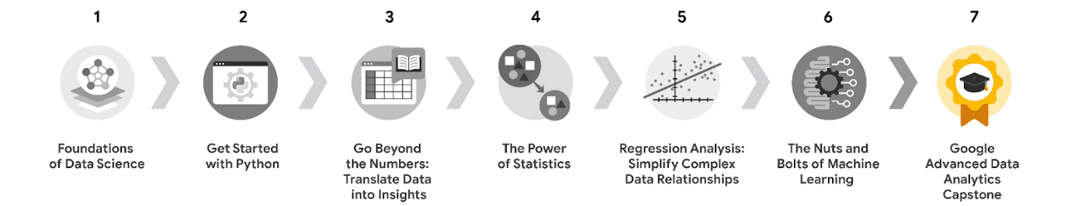

1. [**Foundations of Data Science**](https://www.coursera.org/learn/foundations-of-data-science/home/week/1) — Learnhow data professionals operate in the workplace and how different roles in the field of data science contribute to an organization’s vision of the future. Then, explore data science roles, communication skills, and data ethics.
2. [**Get Started with Python**](https://www.coursera.org/learn/get-started-with-python/home/week/1) —Discover how the programming language Python can power your data analysis. Learn core Python concepts, such as data types, functions, conditional statements, loops, and data structures.
3. [**Go Beyond the Numbers: Translate Data into Insights**](https://www.coursera.org/learn/go-beyond-the-numbers-translate-data-into-insight/home/week/1) — Learn the fundamentals of data cleaning and visualizations and how to reveal the important stories that live within data.
4. [**The Power of Statistics**](https://www.coursera.org/learn/the-power-of-statistics/home/week/1) — Explore descriptive and inferential statistics, basic probability and probability distributions, sampling, confidence intervals, and hypothesis testing.
5. [**Regression Analysis: Simplify Complex Data Relationships**](https://www.coursera.org/learn/regression-analysis-simplify-complex-data-relationships/home/week/1) — Learn to model variable relationships, focusing on linear and logistic regression.
6. [**The Nuts and Bolts of Machine Learning**](https://www.coursera.org/learn/the-nuts-and-bolts-of-machine-learning/home/week/1) — Learn unsupervised machine learning techniques and how to apply them to organizational data.
7. [**Google Advanced Data Analytics Capstone**](https://www.coursera.org/learn/google-advanced-data-analytics-capstone/home/week/1) — *(current course)* Complete a hands-on project designed to demonstrate the skills and competencies you acquire in the program.

**Course 7 content**

Each course of this certificate program is broken into modules. You can complete courses at your own pace, but the module breakdowns are designed to help you finish the entire Google Advanced Data Analytics Certificate in about six months.

What’s to come? Here’s a quick overview of the skills you’ll learn in each module of this course.



**Module 1: Learn about the capstone project**

Similar to the end-of-course projects you’ve already completed, the capstone project was designed to bring together both the content and the skills you have acquired in your previous courses. Although the end-of-course projects focused on individual course learnings, the capstone project incorporates skills and tasks spanning the entire Google Advanced Data Analytics Certificate. The capstone project is optional; it will not affect your ability to receive your certificate. However, it is highly recommended that you demonstrate what you’ve learned in the program by completing this final project! Completing the capstone project is a great way to put together everything you’ve learned, and the final results will be useful for supporting future job applications.

**Module 2: Data-focused career resources**

In this part of the course, you will explore the data hiring process and how to identify appropriate job opportunities. You’ll examine commonalities found within data positions, job titles, and the data skills needed across a variety of industries. Additionally, you’ll discover tips and best practices for communicating your skills and presenting your projects during the job search process. Lastly, you'll gain insight into fine-tuning your resume and portfolio for maximum impact.

**Module 3: Google Advanced Data Analytics Certificate wrap-up**

It’s time to celebrate your completion of the Google Advanced Data Analytics Certificate! You’ll learn how to claim your certificate and receive some final tips on how to best showcase your work examples from the program.

**What to expect**

Each course offers many types of learning opportunities:

* **Videos** led by Google instructors teach new concepts, introduce the use of relevant tools, offer career support, and provide inspirational personal stories.
* **Readings** build on the topics discussed in the videos, introduce related concepts, share useful resources, and describe case studies.
* **Discussion prompts** explore course topics for better understanding and allow you to chat and exchange ideas with other learners in the [**discussion forums**](https://www.coursera.org/learn/google-advanced-data-analytics-capstone/discussions).
* **Self-review activities** and **labs** give you hands-on practice in applying the skills you are learning and allow you to assess your own work by comparing it to a completed example.
* **Interactive plug-ins** encourage you to practice specific tasks and help you integrate knowledge you have gained in the course.
* **In-video quizzes** help you check your comprehension as you progress through each video.
* **Practice quizzes** allow you to check your understanding of key concepts and provide valuable feedback.
* **Graded quizzes** demonstrate your understanding of the main concepts of a course. You must score 80% or higher on each graded quiz to obtain a certificate, and you can take a graded quiz multiple times to achieve a passing score.

**Tips for success**

* It is strongly recommended that you go through the items in each lesson in the order they appear because new information and concepts build on previous knowledge.
* Participate in all learning opportunities to gain as much knowledge and experience as possible.
* If something is confusing, don’t hesitate to replay a video, review a reading, or repeat a self-review activity.
* Use the additional resources that are referenced in this course. They are designed to support your learning. You can find all of these resources in the [**Resources**](https://www.coursera.org/learn/google-advanced-data-analytics-capstone/resources/X8MA3) tab.
* When you encounter useful links in this course, bookmark them so you can refer to the information later for study or review.
* Understand and follow the [Coursera Code of Conduct](https://www.coursera.support/s/article/208280036-Coursera-Code-of-Conduct?) to ensure that the learning community remains a welcoming, friendly, and supportive place for all members.

**Capstone project**

* Select your track
* Project information and data

**Apply skills from across the whole program**

* Python
* EDA
* Data visualizations
* Stats
* Modelling
* PACE

**Introduction to the Course 7 capstone project**

**Welcome to the capstone project!**

Congratulations on reaching the final project of the Advanced Data Analytics certificate program. In this course, you’ll have an opportunity to use skills you developed throughout the entire advanced data analysis program within a single project that is designed to closely simulate the type of work conducted by data analytics professionals. The capstone project is optional, and choosing whether or not to complete it will not affect your ability to receive your certificate. However, it is highly recommended! After completing the capstone project, you will have an entire data analysis project from start to finish, showcasing your skills that you can share with prospective employers.

**What is the capstone project?**

The capstone project is a way for you to apply and assess your newly acquired data analytical skills. In this project, you’ll take on the role of a newly hired data analytics professional. Within the capstone project scenario, you’ll be responsible for tasks like setting up your teams’ workflow, creating a project proposal, carrying out EDA, and building models. Along the way, you’ll interact with a variety of internal and external stakeholders, sharing your insights and final recommendations through an executive summary.

**The capstone project: What to expect**

At the end of each course, you were given an opportunity to use your newly acquired skills within an end-of-course project. Each course’s end-of-course project built on the one before, while breaking down the entire data analysis process into smaller segments. This allowed each end-of-course project to isolate different skills and focus on practicing and reinforcing specific data tasks.

However, in the capstone project, the entire data analysis process is covered by a single project scenario with one project deliverable that showcases the skills you’ve learned across the certificate. To complete this project, you will begin by familiarizing yourself with the capstone project scenario. Next you’ll determine the necessary tasks, and decide the order in which they need to be carried out.

Throughout the capstone project, you will use the skills and experience that you acquired in each course and the accompanying end-of-course projects. The capstone project scenario will offer opportunities to:

* Gather information pertaining to a business problem or an organizational inquiry
* Answer questions relevant to coding with Python
* Conduct exploratory data analysis
* Build statistical data models and machine learning models
* Consider ethical issues related to the task
* Present your findings for a general audience of stakeholders

After completing your capstone project, you’ll be given the opportunity to assess your work through a detailed rubric, designed to offer you valuable feedback. Along the way, you are encouraged to access the [discussion forums](https://www.coursera.org/learn/google-advanced-data-analytics-capstone/discussions) to share your overall strategies, ask questions, and encourage other learners who are working to complete their own capstone projects. (Please note that it’s appropriate to share general project strategies, but not specific steps, processes, or documents!)

**Capstone project scenario overview: Working for Salifort Motors**

**About the company**

Salifort Motors is a fictional French-based alternative energy vehicle manufacturer. Its global workforce of over 100,000 employees research, design, construct, validate, and distribute electric, solar, algae, and hydrogen-based vehicles. Salifort’s end-to-end vertical integration model has made it a global leader at the intersection of alternative energy and automobiles.

**Your business case**

As a data specialist working for Salifort Motors, you have received the results of a recent employee survey. The senior leadership team has tasked you with analyzing the data to come up with ideas for how to increase employee retention. To help with this, they would like you to design a model that predicts whether an employee will leave the company based on their  department, number of projects, average monthly hours, and any other data points you deem helpful.

**The value of your deliverable**

For this deliverable, you are asked to choose a method to approach this data challenge based on your prior course work. Select either a regression model or a tree-based machine learning model to predict whether an employee will leave the company. Both approaches are shown in the project exemplar, but only one is needed to complete your project.

The capstone project will provide you with valuable experience and data analysis examples that you can share with potential employers.

**Key takeaways**

Your capstone project will enable you to apply your newly developed advanced data analytics skills and knowledge, demonstrate fundamental data analysis skills to prospective employers, and present what you have learned from the Grow with Google Advanced Data Analytics Certificate. Providing examples from projects such as the capstone project is an excellent way to showcase your data analytics abilities. The end results from the capstone project greatly strengthen your resume and make you a more competitive candidate for data analytics positions.

**Incorporate your project into a portfolio**

Throughout this certification you have utilized the PACE framework to develop a portfolio project showcasing your workplace and technical skills. Outside of showcasing your projects on your resume, it is important to have an online portfolio that houses your projects. Unlike your resume, which will change frequently based on the job description of the role you are applying for, an online portfolio will only change each time you complete a project. This reading will guide you through how to display your technical skills and projects on your resume and how to create an online project portfolio.

**Add your technical skills and portfolio to your resume**

When applying for a data role, your first introduction to a potential employer is through your resume. When crafting your resume, it is important to add the technical skills you acquired from the certificate and your portfolio project to the “Skills'' section of your resume. Be sure to create a resume that incorporates the technical skills listed in the specific job description. Below is an example of how you can add these technical skills to your resume:

**Example 1: Adding technical skills to your resume**

The following is an example of a “Technical Skills” section that you can include on your resume.

Technical Skills

* Programming Languages: Python
* Python Packages: numpy, Pandas, Scipy, seaborn, Matplotlib, statsmodels, scikit-learn
* Machine Learning Models: regression (linear, logistic), Naive Bayes, decision trees, random forest, AdaBoost, XGBoost

After your technical skills section, you can add a section entitled “Technical Projects”, “Data Projects,” or “Machine Learning Projects.” The title of the section is up to you and depends on the wording of the job description. If the job description repeats the phrase “machine learning,” then you may want to title the section “Machine Learning Projects”. If you have a mix of data projects that include dashboards, data analysis, modeling, etc. you may want to title the section “Data Analytics Projects” and use bullet points to list the different types of projects. Below is an example of how to list a project on your resume:

**Example 2: Add a technical project to your resume**

The following is an example of a “Data Analytics Projects” section that you can include on your resume.

Data Analytics Projects

* Classification of TikTok videos: Used statsmodels and scikit-learn to predict whether videos presented claims or opinions to improve triaging process of videos for human review
* Classification of Waze data: Built decision tree, random forest, and XGBoost to predict Waze user churn
* Used multiple regression to predict taxi fares, data that would be used as part of a suite of models to optimize revenue for the New York Taxi and Limousine Commission and its drivers

The technical skills and projects you add to your resume should also be reflected in your online project portfolio. As you learn more programming languages, technical packages, and models, you need to add them to your resume. The same technical skills you add to your resume should be showcased within the projects you have in your online portfolio. The next section highlights where to build an online portfolio and what to include in your portfolio.

**Where to create your online portfolio**

There are many platforms that data professionals use to host their online portfolios. The first step is to choose a platform that suits the type of projects you want to showcase. Google Sites is good for blog-style portfolios. GitHub and Kaggle are better for hosting code-based portfolios. Tableau is great for sharing your visualizations. Create an account on the platform that you chose.The following links have steps that explain how to set up accounts on various platforms:

* [Set up an account on GitHub](https://docs.github.com/en/github/getting-started-with-github/signing-up-for-a-new-github-account)
* [Set up an account on Kaggle](https://www.kaggle.com/questions-and-answers/122858)
* [Set up an account on Tableau Public](https://public.tableau.com/s/)
* [Set up a site on Google Sites](https://support.google.com/sites/answer/6372878?hl=en&ref_topic=7184580)

Since Github is one of the most popular platforms for creating an online project portfolio, the next section will demonstrate what to add to your GitHub Portfolio in more detail.

**What to add to your GitHub Portfolio**

After setting up a github account, you will need to create separate repositories for each individual project. Each repository will contain all of your project files and a README.md file. A README is a markdown-based text file that provides an overview of your project. The following sections are great to include in your README:

* Project Title
  + Including a descriptive title that states the type of analysis and project draws in your prospective employer. Do not title your project “Portfolio Project”; instead try adding the modeling algorithm and data used to your title. For example: “Natural Language Processing of Election Day Tweets.”
* Project Overview
  + A project overview should be a few sentences long stating the problem you solved, what data was used in the project, and your modeling results.
* Business Understanding
  + You should have a section that showcases the stakeholder(s) and the business problem you tried to solve. Feel free to add citations of research you did on your business problem here as well.
* Data Understanding
  + Explain what data you used in your analysis, the timeframe of the data, and any data limitations. This is also a good section to add visualizations of your exploratory data analysis.
* Modeling and Evaluation
  + This section should detail what models you used and the corresponding evaluation metrics.
* Conclusion
  + In the conclusion section explain the recommendations you have in solving the business problem and highlight any future steps you will take to expand on your project,

For more information on how to craft README files, checkout GitHub’s [“About READMEs”](https://docs.github.com/en/repositories/managing-your-repositorys-settings-and-features/customizing-your-repository/about-readmes) article.

The Github repository README (shown below) uses the New York City Taxi & Limousine Commission data that you have seen in your portfolio project throughout the program. This example expands beyond what was given in your original project description by including domain knowledge under the “Business Understanding” section. Domain knowledge demonstrates to a prospective employer your ability to do research before conducting a technical analysis. It is important to create a clear, concise README that summarizes your business understanding and technical findings.

**Example Project: README**

Predicting Taxi Gratuities in New York City

**Overview**

The goal of this project was to create a multiple linear regression and random forest model to predict high rider gratuity or not. This project utilized yellow taxi trips taken in New York City during 2017. The final random forest model performed with 86% accuracy and 72% precision determining what features were most important in separating low tippers from high tippers. Based on the model, the duration, distance, and cost of the trip were most influential in determining a generous tipper (>20%) vs a non-generous one (<20%).

**Business Understanding**

According to salary.com the average salary for a New York Taxi Driver is around $45,000. This salary is significantly low compared to a median rent value of $6,500 per month. It is important to understand what factors encourage riders to leave tips in order to help drivers obtain a livable wage.

**Data Understanding**

The NYC Taxi and Limousine Commission data came from [NYC.gov](https://www.nyc.gov/site/tlc/about/tlc-trip-record-data.page). The data consisted of approximately 408k unique trips and 18 features. The features included information on trip duration and destination, vendor used, toll information, and payment type. The bar chart below shows the breakdown of how many generous tippers (>20%) versus non-generous tippers that exist in the data set.

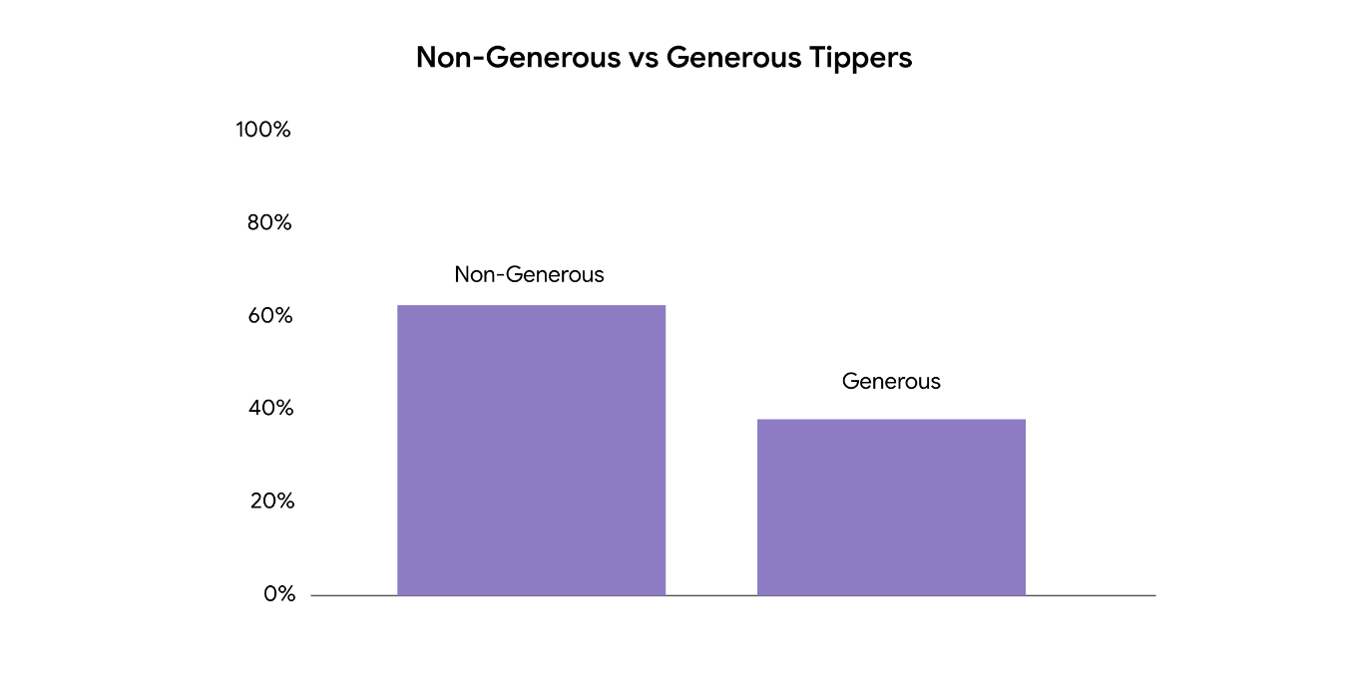

In connection to this, a feature was engineered to represent if a ride was taken during rush hour or not. Multiple redundant columns were dropped and reformatted into the proper data type.

**Modeling and Evaluation**

A random forest model comprising 100 decision trees was used to determine feature importance in who would tip generously or not. The below plot shows that trip duration, distance, and the cost of a fare were the Top 3 most important factors in determining a generous tipper from a non-generous one. The overall model performed with 86% accuracy and 72% precision.

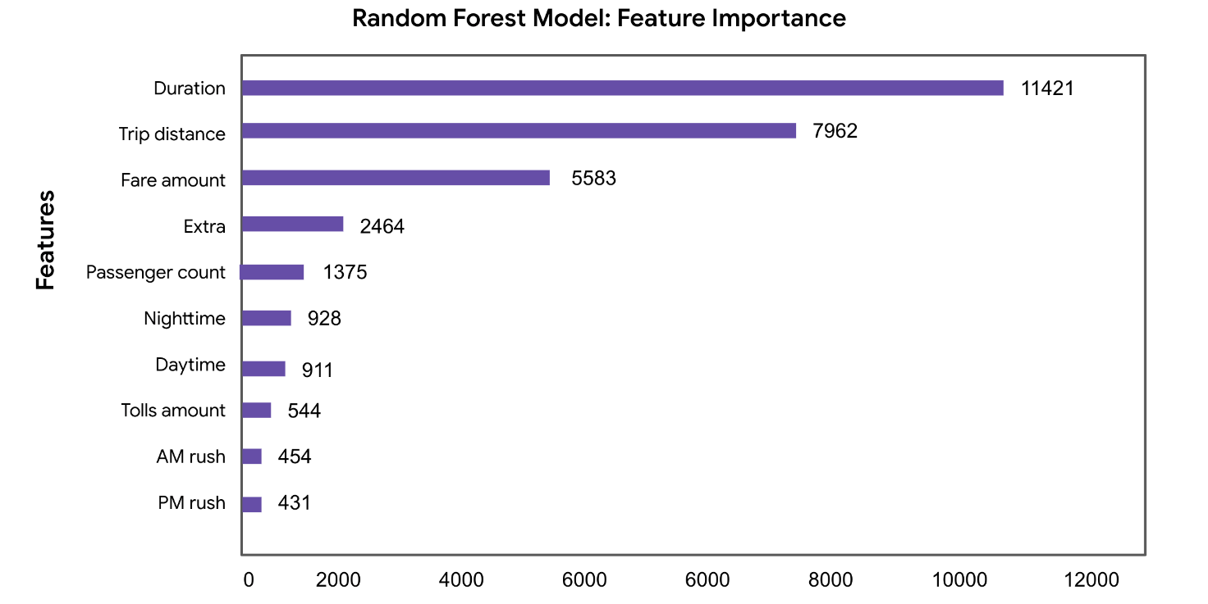

**Conclusion**

This model can benefit Taxi Drivers in knowing if they will be tipped generously or not; however, running a parametric model to determine how much each variable will influence the actual price of the tip. In the future, adding more information on a rider’s past tipping behavior may also be beneficial in helping the stakeholder address their business problem.

Outside of the README file, it is important to have the data you used, cleaned up Python notebook files, a presentation, and any images you may have used on your GitHub repository.

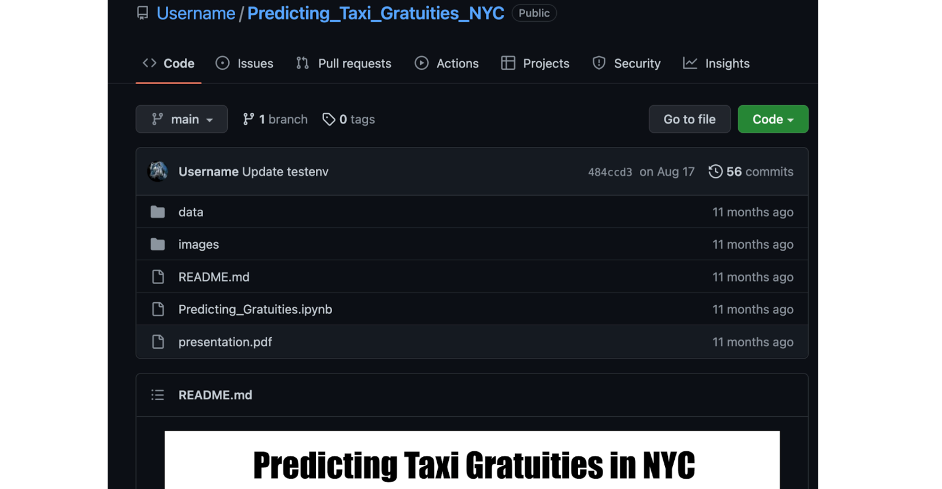

Checkout this additional resource from [DataQuest](https://www.dataquest.io/blog/how-to-share-data-science-portfolio/) that walks you through how to add files to your online Github portfolio. The goal is to have all project information in one repository that will help an employer understand your project, run your code, and clearly know your business recommendations.

**Key Takeaways**

* You should review the job description’s technical skills and add the applicable skills to your resume to increase your chances for being called for an interview.
* Having your data projects on your resume is a great way to showcase your hands-on technical experience for various data roles.
* Github is a great online platform for building an online portfolio of coding projects that can be seen by any prospective employer. Keep in mind that there are other platforms: Kaggle, Google Sites, Tableau Public, Medium, and more R can showcase your technical writing, data visualization, and coding skills.

**Use the capstone to your advantage**

* Add to your portfolio
* Share with potential employers
* Discuss in interviews
* Share your models and PACE strategy document

To pass this practice quiz, you must receive 100%, or 1 out of 1 point, by completing the activity below. You can learn more about the graded and practice items in the [course overview](https://www.coursera.org/learn/google-advanced-data-analytics-capstone/supplement/jh70x/course-7-overview).

**Activity Overview**

In this activity, you will showcase your ability to use Python for model building and data analysis. You will deploy different models to analyze a dataset and generate business insights for your stakeholders. In particular, you will build and evaluate a logistic regression model or the following machine learning models: decision tree, random forest, XGBoost. You will also update your stakeholders through an executive summary, demonstrating your ability to organize and communicate key information.

Be sure to complete this activity before moving on. The next course item will provide you with completed exemplars to compare to your own work. You will not be able to access the exemplars until you have completed this activity.

**Scenario**

Review the scenario below. Then complete the step-by-step instructions.

You are a data professional working for Salifort Motors.

Currently, there is a high rate of turnover among Salifort employees. (Note: In this context, turnover data includes both employees who choose to quit their job and employees who are let go). Salifort’s senior leadership team is concerned about how many employees are leaving the company. Salifort strives to create a corporate culture that supports employee success and professional development. Further, the high turnover rate is costly in the financial sense. Salifort makes a big investment in recruiting, training, and upskilling its employees.

If Salifort could predict whether an employee will leave the company, and discover the reasons behind their departure, they could better understand the problem and develop a solution.

As a first step, the leadership team asks Human Resources to survey a sample of employees to learn more about what might be driving turnover.

Next, the leadership team asks you to analyze the survey data and come up with ideas for how to increase employee retention. To help with this, they suggest you design a model that predicts whether an employee will leave the company based on their job title, department, number of projects, average monthly hours, and any other relevant data points. A good model will help the company increase retention and job satisfaction for current employees, and save money and time training new employees.

As a specialist in data analysis, the leadership team leaves it up to you to choose an approach for building the most effective model to predict employee departure. For example, you could build and evaluate a statistical model such as logistic regression. Or, you could build and evaluate machine learning models such as decision tree, random forest, and XGBoost. Or, you could choose to deploy both statistical and machine learning models.

For any approach, you’ll need to analyze the key factors driving employee turnover, build an effective model, and share recommendations for next steps with the leadership team.

\_\_\_\_\_\_\_\_\_\_\_\_\_\_\_\_\_\_\_\_\_\_\_\_\_\_\_\_\_\_\_\_\_\_\_\_\_\_\_\_\_\_\_\_\_\_

**Step-By-Step Instructions**

Follow the instructions to complete the activity. Then, go to the next course item to compare your work to a completed exemplar.

Step 1: Access the templates

To use the templates for this course item, click each link below and select *Use Template*.

Link to templates:

* [Course 7 PACE strategy document](https://docs.google.com/document/d/1pUorT_9CyyLNdSylj_KIaAy1dkjtqzLjIKsyHfqSblU/template/preview?resourcekey=0-1EeMIpVgUnjiF6bdfSsd0g)
* [Executive summary templates](https://docs.google.com/presentation/d/1Pps5GKxi1V31y2oRHRzU-xhJubkEYzCgEIfNjlEY3Og/template/preview#slide=id.g1390e7c1ade_0_62)

**OR**

If you don’t have a Google account, you can download the templates directly from the attachments below:

[Activity Template\_ Course 7 PACE strategy document](https://d3c33hcgiwev3.cloudfront.net/g6FgRcIESsqaIfLuPFJzSg_431833d72f434614af88cf1d8f4d12f1_Activity-Template_-Course-7-PACE-strategy-document.docx?Expires=1727308800&Signature=A8PD1iHJP9uOSLXgaYQUY3Ybsi~qTXVg8LOD-MjQ2YZw5IwmRWIMzmJRhaSVdXmArWgtdhRtBo3KHzreVQqdHTUjOXnv3IwBGGwZCA1tHcxpAgo8NoK-ae8MaBXNrS9morv~1MgyyCA1rfePSTWznUu8Gz2FS~P~3xPMPSHdBLo_&Key-Pair-Id=APKAJLTNE6QMUY6HBC5A" \t "_blank)

[DOCX File](https://d3c33hcgiwev3.cloudfront.net/g6FgRcIESsqaIfLuPFJzSg_431833d72f434614af88cf1d8f4d12f1_Activity-Template_-Course-7-PACE-strategy-document.docx?Expires=1727308800&Signature=A8PD1iHJP9uOSLXgaYQUY3Ybsi~qTXVg8LOD-MjQ2YZw5IwmRWIMzmJRhaSVdXmArWgtdhRtBo3KHzreVQqdHTUjOXnv3IwBGGwZCA1tHcxpAgo8NoK-ae8MaBXNrS9morv~1MgyyCA1rfePSTWznUu8Gz2FS~P~3xPMPSHdBLo_&Key-Pair-Id=APKAJLTNE6QMUY6HBC5A" \t "_blank)

[Activity Templates\_ Executive summaries](https://d3c33hcgiwev3.cloudfront.net/dsJAWJx-Q-COlR03Tm64ew_c820170fbfc840bca08d6b234846caf1_Activity-Templates_-Executive-summaries.pptx?Expires=1727308800&Signature=IBvAlfZnwMRmlQa9S-EicMVUjLAqbYdn2zqN2u5JQVMVOp~dsirANhc9ep2XwlAG4emRukCixscWJrBA29IS3-mdiv0GD2W4leGr6e7sznZmoCSIPIt2I59BXMPPmsz-2SfAO4jVOqSg3rwNLJGfnHDvD5okgPfN51-czqYq4aU_&Key-Pair-Id=APKAJLTNE6QMUY6HBC5A" \t "_blank)

[PPTX File](https://d3c33hcgiwev3.cloudfront.net/dsJAWJx-Q-COlR03Tm64ew_c820170fbfc840bca08d6b234846caf1_Activity-Templates_-Executive-summaries.pptx?Expires=1727308800&Signature=IBvAlfZnwMRmlQa9S-EicMVUjLAqbYdn2zqN2u5JQVMVOp~dsirANhc9ep2XwlAG4emRukCixscWJrBA29IS3-mdiv0GD2W4leGr6e7sznZmoCSIPIt2I59BXMPPmsz-2SfAO4jVOqSg3rwNLJGfnHDvD5okgPfN51-czqYq4aU_&Key-Pair-Id=APKAJLTNE6QMUY6HBC5A" \t "_blank)

Step 2: Access the capstone project lab

***Note****: The following lab is also the next course item. Once you complete and submit your activity, return to the lab instructions’ page and click* ***Next*** *to continue on to the exemplar reading.*

To access the lab, click the link below and select *Open Lab:*

* [Course 7 capstone lab](https://www.coursera.org/learn/google-advanced-data-analytics-capstone/ungradedLab/uskOX/activity-course-7-salifort-motors-project-lab)

Your Python notebook for this project includes a guided framework that will assist you with the required coding. Input the code and answer the questions in your Python notebook to build and evaluate a logistic regression model or the following machine learning models: decision tree, random forest, XGBoost. You’ll find helpful reminders for tasks like:

* Exploratory data analysis (EDA)
* Model building and evaluation

You will also discover questions in this Python notebook designed to help you gather the relevant information you’ll need to write an executive summary for your stakeholders.

Use your completed PACE strategy document and Python notebook to help you prepare your executive summary.

Data Dictionary

This project uses a dataset called **HR\_capstone\_dataset.csv.** It represents 10 columns of self-reported information from employees of a multinational vehicle manufacturing corporation.

The dataset contains:

14,999 rows – each row is a different employee’s self-reported information

10 columns

| **Column name** | **Type** | **Description** |
| --- | --- | --- |
| satisfaction\_level | int64 | The employee’s self-reported satisfaction level [0-1] |
| last\_evaluation | int64 | Score of employee's last performance review [0–1] |
| number\_project | int64 | Number of projects employee contributes to |
| average\_monthly\_hours | int64 | Average number of hours employee worked per month |
| time\_spend\_company | int64 | How long the employee has been with the company (years) |
| work\_accident | int64 | Whether or not the employee experienced an accident while at work |
| left | int64 | Whether or not the employee left the company |
| promotion\_last\_5years | int64 | Whether or not the employee was promoted in the last 5 years |
| department | str | The employee's department |
| salary | str | The employee's salary (low, medium, or high) |

Step 3: Complete your PACE strategy document



The **Capstone PACE strategy document** includes questions that will help guide you through the Course 7 employee data project. Answer the questions in your PACE strategy document to prepare for using Python to build and evaluate statistical, regression, and/or machine learning model(s) to analyze your data.

As a reminder, the PACE strategy document is designed to help you complete the contents for each of the templates provided. You may navigate back and forth between the PACE strategy document and the Python notebook as needed.

Step 4: Prepare an executive summary

Your executive summary will keep the senior leadership team at Salifort Motors informed of your progress. The one-page format is designed to respect teammates and stakeholders who might not have time to read and understand a lengthy technical report.

First, select one of the executive summary design layouts from the provided template.

Then, add the relevant information. Your executive summary should include the following:

* A summary of the benefits and limitations of your regression, or machine learning model(s)
* The results of your analysis
* Recommendations or insights based on your results, including recommended next steps

Finally, complete your executive summary to effectively communicate your findings to your stakeholders. Ensure that the model’s limitations are addressed, model results are clearly stated, and next steps are identified.

**Pro Tip: Save the templates**

Finally, be sure to save a blank copy of the templates you used to complete this activity. You can use them for further practice or in your professional projects. These templates will help you work through your thought processes and demonstrate your experience to potential employers.

**What to Include in Your Response**



**Course 7 PACE strategy document:**

* Answer the questions in the PACE strategy document

**Course 7 capstone lab:**

* Build and evaluate a logistic regression model

or

* Build and evaluate the following machine learning models: decision tree, random forest, XGBoost

**Course 7 executive summary:**

* Summarize the benefits and limitations of your regression, or machine learning model(s)
* Identify the results of your analysis
* Include recommendations or insights based on your results

**1.**

Question 1

Did you complete this activity?

Status: [object Object]

1 point

Yes

## **Module 2:**

**Generic search for a data position**

* Data scientist
* Data analyst
* Assistant data analyst

**Searching for data jobs**

* LinkedIn
* Indeed
* Glassdoor
* Google Search

**Communicate your skills and assets**

Throughout this certificate program, you have been taught professional and technical skills that can be utilized across many data roles within various industries. Being able to communicate about these skills in an effective way is important when pursuing a career as a data professional. This reading covers strategies on how to communicate your newly-acquired skills to prospective employers during interviews.

**Communicate technical skills in interviews**

In your portfolio projects, you practiced explaining data concepts to various audiences through executive summaries. During your job search, you will send your resume and portfolio to hiring managers and decision-makers. Most often, the person who receives your information is not deeply-versed in data analysis. The information that you provide needs to be presented in an accessible manner throughout all stages of the interview process. Often, the interview process starts with the company’s human resources department, where the interviewer may not understand the technical details of how you conducted your data-focused work. The below section describes how you can talk about your projects at a high level within your elevator pitch during an initial interview.

**Explain technical projects and skills during initial interviews**

For initial interviews,  your main goal is to answer the question, “What can you tell me about yourself?” When answering this question, you want to make sure to showcase your experience in the role you are applying for and what excites you about the role. You should present a clear, non-technical summary of your technical projects in an elevator pitch. An **elevator pitch** is a short, one-minute introduction that states why you are best suited for the role. The elevator pitch below describes the candidate’s experience working on a project similar to those they would be working on in the role for which they are applying.

“Recently, I earned a Google Advanced Data Analytics Certificate, during which I completed a technical project on predicting customer churn for a telecommunications company. This project used customer demographics, call center data, and phone usage data to predict whether a customer would cancel their service plan or not. After running several machine learning models, I noticed that customers who called the call center for support more than three times or had a family plan were seven times more likely to churn. Based on these findings, I recommended the stakeholders gather survey feedback about the quality of support customers are receiving from the call center and implement a money-saving promotion for customers on family plans. I feel this project aligns well with the open position in providing analysis for how to retain customers.”

Draft an elevator pitch that includes an example of a technical project you’ve worked on. It is important that when talking to prospective employers, you sound authentic and natural, so be sure to practice your pitch aloud. For more tips on how to develop an elevator pitch, review this LinkedIn article: [How to Craft a Perfect Job Interview Elevator Pitch](https://www.linkedin.com/pulse/how-craft-perfect-job-interview-elevator-pitch-renata-junkova).

**Use the STAR method to answer technical questions in behavioral interviews**

Behavioral interviews are used to help hiring managers understand how you handle common situations in the workplace. These situations can include your interactions with clients or stakeholders, how you handle criticism, how you manage your time, your leadership skills, and more. One of the most common ways to answer behavioral questions is by using the STAR method. STAR stands for **situation**, **task**, **action**, and **results**. Below is an example of how this method might be used to answer the question, “What was the biggest challenge you faced in performing an analysis?”

**STAR responses:**

* **Situation**: “In my prior role for Company XYZ, my team was working with a stakeholder who wanted to forecast revenue for 30 of their stores.”
* **Task**: “I was tasked with acquiring each of the 30 stores' financial data from the past 10 years in a secure way. “
* **Action**: “Acquiring the data was challenging due to a lack of access to the stores’ legacy data and systems. After getting to know one of the store’s data systems, I trained managers from the remaining stores so that they could provide access and share the data we needed for the analysis.”
* **Result**: “As a result, we were able to complete the analysis a month ahead of schedule.”

Even if you are just entering the workforce or changing careers, you can think of situations from your portfolio projects, past academic experiences, and volunteer work to share with the employer.

**Showcase your skills during technical interviews**

Technical interviews can take place at any point throughout the interview process. Here are a couple types of technical interviews and suggestions for how to prepare yourself for technical questions:

**Online technical assessments**

You may be given an online technical assessment before or after your initial human resources interview. These online assessments will usually assess the technical skills outlined in the job description and may or may not be timed. In order to adequately prepare for an online technical assessment:

* Review the skill requirements in the job description to determine what technical content to focus on.
* Ask the hiring manager for additional details about the assessment process (e.g., areas of focus, how the assessment will be scored, format of the test , etc.).
* Research the company to get a sense of the types of technical projects they focus on.

**Pro tip**: If the assessment is a coding exercise, adding comments to your code can help demonstrate your technical communication skills, logical thinking, and deductive reasoning.

**Case studies**

Case studies simulate the types of projects you may be asked to work on as an employee.  There are case studies centered around business, analytics, and machine learning. Utilize these four steps to answer case study interview questions:

* **Step 1: Clarify**. Asking clarifying questions about the case can demonstrate that you can communicate effectively and care about the details of the case presented to you. Consider asking clarifying questions around business goals, how the model will be used, what tools are available for you to conduct the analysis, and other questions that would give you more insight into the goal of the project.
* **Step 2: State assumptions.** After clarifying what the overall case study is about, communicate what assumptions you can make about the case. Can you assume that there will be a certain target audience, a certain amount of data provided, preliminary data exploration, or hypothesis testing? Stating these assumptions demonstrates that you can infer relevant information and navigate through problems well.
* **Step 3: Propose a solution**. There normally isn’t only one right solution to any given case. Use all the information you gathered from your clarifying questions and assumptions to propose a logical solution.
* **Step 4: Provide an analysis.** Back up your proposed solution with the data and analysis you would need to perform. Communicate what data features would you need, how much data would you collect, and what hypothesis tests you would perform.

As you answer case study interview questions, it is important to take the interviewer through the entire PACE workflow so that they can get a sense of both your professional and technical skills.  It is also helpful to connect the case to a similar project you have worked on in an academic or professional setting.

**Key takeaways**

* An elevator pitch is a concise introduction to who you are, what makes you qualified for the role, and why you are excited about working for that company. An elevator pitch may include details about a technical project you have worked on in the past and how it relates to the role you are applying for.
* Behavioral interviews focus on how you handle professional situations in the workplace. Use the STAR method (situation, task, action, result) to showcase your professional skills in various situations.
* Technical interviews can include online coding assessments, case studies, and more. Knowing what technical skills are required in the job description can help you prepare for the technical questions that may be asked during the interview. Reflecting on how you utilized these technical skills on past projects is also beneficial.

**Portfolio**

A collection of materials that can be shared with potential employers

**1.**

Question 1

When refocusing your resume for a specific job application, it may help to revise the descriptions on your resume to reflect language used in the job posting.

Status: [object Object]

1 / 1 point

True

False

Correct

When refocusing your resume for a specific job application, it may be beneficial to revise the descriptions on your resume to reflect language used in the job posting. To do this, review the requirements for the position and take note of areas within your resume that illustrate the skills listed in the job posting. Then, revise sections that could be better aligned.

**2.**

Question 2

Fill in the blank: In order to \_\_\_\_\_ your resume, include technical and software proficiencies, such as the languages, platforms, and software that you have used to analyze data.

Status: [object Object]

1 / 1 point

formalize

specialize

standardize

normalize

Correct

In order to specialize your resume, include technical and software proficiencies, such as the languages, platforms, and software that you have used to analyze data. For this program, consider adding Python and Tableau, as well as previous work and educational experiences you have with other data-related software.

**3.**

Question 3

What should you do if you want to apply for a job, but the description includes programming languages or software applications that you are unfamiliar with?

Status: [object Object]

1 / 1 point

Do not apply for the job.

Describe the skills you have that may be transferable to those listed in the position, then highlight them on your resume.

Include the programming languages and software applications on your resume, even if you do not know them.

Note in your cover letter that you do not have these skills, but hope they will consider you anyway.

Correct

If you want to apply for a job, but the description includes programming languages or software that you are unfamiliar with, describe skills you have that may be transferable to those listed in the position. Also consider adding context about how you can be proficient in the role.

**Proactive approaches to the interview process**

Throughout your career, potential employers will interview you as part of the job application process. Improving your interviewing skills takes practice, and it is an important part of a data professional’s communication tool kit. In this reading, you’ll learn how best to prepare for an interview and things to remember during an interview.

**Prepare for an interview**

An interview with a new company often represents the final phase of a job search process. It is never too early to prepare for that step. Whether you’ve been asked to be interviewed already, or are still in the networking and applying phase, interview preparation will help you feel confident when the time comes.

**Here are a few ideas to help you get started in your interview prep:**

* **Review the job skills and responsibilities.** A job posting lists the requirements, duties, and responsibilities of the role. This makes it a key resource for interview preparation. To start, review the requirements in the job posting. Consider your job experiences, education, and certifications, and how these things line up with the listed requirements. Think about how you can share experiences that meet the requirements, and provide evidence that you can handle the listed roles and responsibilities.
* **Conduct background research.** This can entail various steps:
  + Study the business that posted the job listing, including its history, mission statement, product/service offerings, etc. If you found the job posting on a professional networking site like LinkedInⓇ, consult the company's webpage for additional information beyond the job post.
  + Ask for the names and titles of your interviewer(s) to get an idea of their career path and what types of questions they may ask.
  + Research the company’s recent press releases or public announcements. If the opportunity presents itself, you can merge a recent announcement into one of your answers to demonstrate that you are familiar with the company.
* **Gather experiential examples.** Think of some examples of times you solved a problem, led a team, developed a project, or brought structure to ambiguous circumstances. These are great experiences to describe when interviewers ask behavioral questions, such as:
  + *Tell me about a time you disagreed with a superior’s decision or approach. What did you do and what was the result?*
  + *Tell me about a project or accomplishment you’re proud of.*
  + *Give an example of a time you weren’t sure how to solve an issue. How did you resolve it?*

**Online video interviews versus in-person interviews**



Whether your job interview is in person or virtual, you should proactively prepare for them accordingly. Here are some tips to consider for both interview settings:

| **In-Person Interview Tips** | **Online Video Interview Tips** |
| --- | --- |
| * Print several copies of your resume and bring them with you—just in case * Arrive to the interview early * Dress appropriately in business casual or business formal attire, basing the decision on what you know about company culture from your research * Bring data visualizations and/or a data portfolio that you can leave with your interviewers | * Prepare your room background or a virtual background—keep it professional * Consider acquiring a video call light and a USB microphone * Before the interview, get familiar with the interviewer’s chosen platform, ensure you know how to navigate and use it * Check that your computer’s microphone, speakers, and camera are working before the interview * Dress as if you were going to the office, even if you’re interviewing from home |

**During an interview**

* **Answer interview questions fully, but concisely.** Interviews tend to average between 20 and 60 minutes—that’s not a lot of time to share all of your relevant work experiences. Listen carefully to the interviewer’s questions and answer each question fully, without embellishment, using your most important work experiences.
* **Find connections between the job listing and your resume.** As you respond to interview questions, include specific keywords or phrases from the job description you studied during your research. Seek to align your skills, certifications, and experiences with what is described in the job listing.
* **Get technical.** As you start to think about things you want to highlight in your interview, remember that data professional job interviews tend to get quite technical. Be prepared to answer questions or perform tasks regarding exploratory data analysis (EDA), coding, regression, statistics, and even machine learning.
* **Come ready with your own questions.** Interviews are a chance to learn more about the company, the team, or the role that aren’t already publicly available. For example:
  + *If hired, what are some upcoming projects I’d be working on?*
  + *What are some goals the team is currently focused on?*
  + *Can you tell me about the team members I’ll be working with?*

**Consider your mindset**

Approach the interview with a confident mindset. Employers appreciate aconfident candidate because confidence reflects solid experience and quality job performance. One important way to have a confident mindset before and during an interview is to remember that an interview is not only an opportunity for a company to decide whether you’re a good fit for them–it’s also an opportunity for you to decide whether the company is a good fit for *you*. When you are well prepared and your mindset is focused on the value you offer a company, confidence naturally follows.

**Key takeaways**

Job interviews are a useful part of your job search. As you continue in your data professional career, think about preparations you can make for potential interviews. Whether in person or virtual, preparing for interviews can help you have confidence, which allows you to present yourself and your experiences in the best way possible.

**Prepare for interviews with Interview Warmup**

Now that you have developed new skills and knowledge in advanced data analytics, it’s time to start preparing for interviews. [Interview Warmup](http://grow.google/interview-warmup) is a tool that helps you practice answering questions to become more confident and comfortable throughout the interview process.

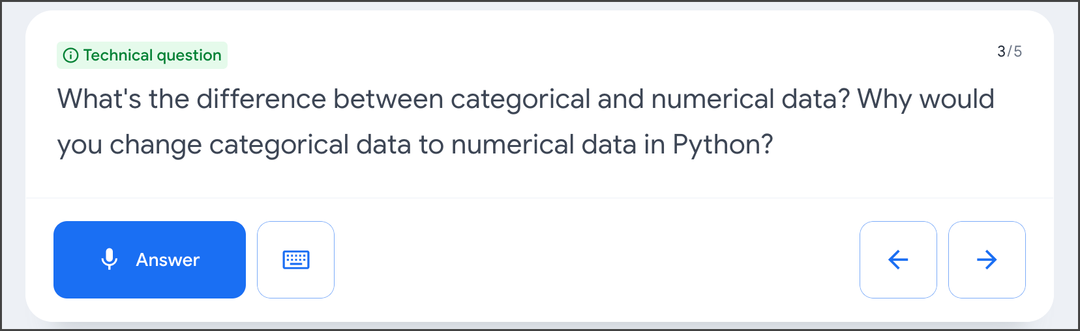

**Get started**

Follow these steps to start a five-question practice interview related to advanced data analytics:

1. Go to [grow.google/interview-warmup](http://grow.google/interview-warmup).
2. Click **Start practicing**.
3. Select **Data Analytics** to open an additional menu.
4. Select **Advanced Data Analytics** as the field you wish to practice.
5. Click **Start**.

The interview lasts about 10 minutes, and the questions will vary with each attempt. During each interview session, you will be asked two background questions, one behavioral question, and two technical questions. You are encouraged to try as many practice interviews as you want.

You can also review complete lists of [data analytics interview questions](https://grow.google/certificates/interview-warmup/category/advanced-data-analytics/all-questions/) or [general interview questions](https://grow.google/certificates/interview-warmup/category/general/all-questions/) if you'd like to focus on a particular topic.

**How it works**

Interview Warmup asks you interview questions to practice delivering your responses verbally. Your answers will be transcribed in real time, allowing you to review how you responded. In addition, Interview Warmup's machine learning algorithm can detect insights that can help you learn more about your answers and improve the way you communicate.

Here are a few examples of questions Interview Warmup might ask:

* Describe a successful workflow for a data project. What makes this workflow effective?
* Tell me about a time that you struggled with exploratory data analysis. What was the source of your struggle? What did you learn as a result?
* Explain a probability distribution that is not normal and how to apply that in the workplace.
* How do you evaluate the performance of a linear regression model?
* What are two types of machine learning, and what are the distinctions between them?

Here are some of the insights that Interview Warmup provides:

* **Talking points:** The tool lets you know which topics you covered in your answer, such as your experience, skills, and goals. You’ll also be able to view other topics that you might want to consider covering.
* **Most-used words:** The tool highlights the words you used most often and suggests synonyms to broaden your word choices.
* **Job-related terms:** The tool highlights the words you used that are related to the role or industry in which you are preparing to work. You’ll also be able to view an entire list of job-related terms that you might want to consider including in your answer.

Interview Warmup gives you the space to practice and prepare for interviews on your own. Your responses will be viewable only by you, and they won’t be graded or judged.

**Key takeaways**

Practicing for interviews is an important step in furthering your career in data analytics. Using Interview Warmup can help you practice interview questions and receive feedback in real time. As you practice, you will gain confidence and be able to prepare more polished responses for common interview questions.

**1.**

Question 1

During a job search, what are some strategies you can use to familiarize yourself with the company you are hoping to work for? Select all that apply.

Status: [object Object]

1 / 1 point

Understand the company’s mission statement.

Correct

During a job search, it’s beneficial to visit the company’s website to learn about its history, understand the mission statement, and research the company on career sites.

Research the company on career sites, such as LinkedIn.

Correct

During a job search, it’s beneficial to visit the company’s website to learn about its history, understand the mission statement, and research the company on career sites.

Contact the hiring manager to ask any questions you may have about the company before your interview.

Visit the company’s website to learn about its history.

Correct

During a job search, it’s beneficial to visit the company’s website to learn about its history, understand the mission statement, and research the company on career sites.

**2.**

Question 2

A successful portfolio may include data models, structured data, an A/B test, and data visualizations that you have worked on during this program.

Status: [object Object]

1 / 1 point

True

False

Correct

A successful portfolio may include data models, structured data, an A/B test, and data visualizations that you have worked on during this program. It can also include linear regression and machine learning models.

**3.**

Question 3

While at an interview, you share your data experiences and portfolio. Which stage of the PACE framework does this describe?

Status: [object Object]

1 / 1 point

Plan

Analyze

Construct

Execute

Correct

This describes the Execute stage. During your interview, you will put your plan into action to secure a position in the organization by sharing your experiences and portfolio, with the goal of taking the next steps in your data professional career.

**Proactive approaches to the interview process**

Throughout your career, potential employers will interview you as part of the job application process. Improving your interviewing skills takes practice, and it is an important part of a data professional’s communication tool kit. In this reading, you’ll learn how best to prepare for an interview and things to remember during an interview.

**Prepare for an interview**

An interview with a new company often represents the final phase of a job search process. It is never too early to prepare for that step. Whether you’ve been asked to be interviewed already, or are still in the networking and applying phase, interview preparation will help you feel confident when the time comes.

**Here are a few ideas to help you get started in your interview prep:**

* **Review the job skills and responsibilities.** A job posting lists the requirements, duties, and responsibilities of the role. This makes it a key resource for interview preparation. To start, review the requirements in the job posting. Consider your job experiences, education, and certifications, and how these things line up with the listed requirements. Think about how you can share experiences that meet the requirements, and provide evidence that you can handle the listed roles and responsibilities.
* **Conduct background research.** This can entail various steps:
  + Study the business that posted the job listing, including its history, mission statement, product/service offerings, etc. If you found the job posting on a professional networking site like LinkedInⓇ, consult the company's webpage for additional information beyond the job post.
  + Ask for the names and titles of your interviewer(s) to get an idea of their career path and what types of questions they may ask.
  + Research the company’s recent press releases or public announcements. If the opportunity presents itself, you can merge a recent announcement into one of your answers to demonstrate that you are familiar with the company.
* **Gather experiential examples.** Think of some examples of times you solved a problem, led a team, developed a project, or brought structure to ambiguous circumstances. These are great experiences to describe when interviewers ask behavioral questions, such as:
  + *Tell me about a time you disagreed with a superior’s decision or approach. What did you do and what was the result?*
  + *Tell me about a project or accomplishment you’re proud of.*
  + *Give an example of a time you weren’t sure how to solve an issue. How did you resolve it?*

**Online video interviews versus in-person interviews**



Whether your job interview is in person or virtual, you should proactively prepare for them accordingly. Here are some tips to consider for both interview settings:

| **In-Person Interview Tips** | **Online Video Interview Tips** |
| --- | --- |
| * Print several copies of your resume and bring them with you—just in case * Arrive to the interview early * Dress appropriately in business casual or business formal attire, basing the decision on what you know about company culture from your research * Bring data visualizations and/or a data portfolio that you can leave with your interviewers | * Prepare your room background or a virtual background—keep it professional * Consider acquiring a video call light and a USB microphone * Before the interview, get familiar with the interviewer’s chosen platform, ensure you know how to navigate and use it * Check that your computer’s microphone, speakers, and camera are working before the interview * Dress as if you were going to the office, even if you’re interviewing from home |

**During an interview**

* **Answer interview questions fully, but concisely.** Interviews tend to average between 20 and 60 minutes—that’s not a lot of time to share all of your relevant work experiences. Listen carefully to the interviewer’s questions and answer each question fully, without embellishment, using your most important work experiences.
* **Find connections between the job listing and your resume.** As you respond to interview questions, include specific keywords or phrases from the job description you studied during your research. Seek to align your skills, certifications, and experiences with what is described in the job listing.
* **Get technical.** As you start to think about things you want to highlight in your interview, remember that data professional job interviews tend to get quite technical. Be prepared to answer questions or perform tasks regarding exploratory data analysis (EDA), coding, regression, statistics, and even machine learning.
* **Come ready with your own questions.** Interviews are a chance to learn more about the company, the team, or the role that aren’t already publicly available. For example:
  + *If hired, what are some upcoming projects I’d be working on?*
  + *What are some goals the team is currently focused on?*
  + *Can you tell me about the team members I’ll be working with?*

**Consider your mindset**

Approach the interview with a confident mindset. Employers appreciate aconfident candidate because confidence reflects solid experience and quality job performance. One important way to have a confident mindset before and during an interview is to remember that an interview is not only an opportunity for a company to decide whether you’re a good fit for them–it’s also an opportunity for you to decide whether the company is a good fit for *you*. When you are well prepared and your mindset is focused on the value you offer a company, confidence naturally follows.

**Key takeaways**

Job interviews are a useful part of your job search. As you continue in your data professional career, think about preparations you can make for potential interviews. Whether in person or virtual, preparing for interviews can help you have confidence, which allows you to present yourself and your experiences in the best way possible.

**Prepare for interviews with Interview Warmup**

Now that you have developed new skills and knowledge in advanced data analytics, it’s time to start preparing for interviews. [Interview Warmup](http://grow.google/interview-warmup) is a tool that helps you practice answering questions to become more confident and comfortable throughout the interview process.

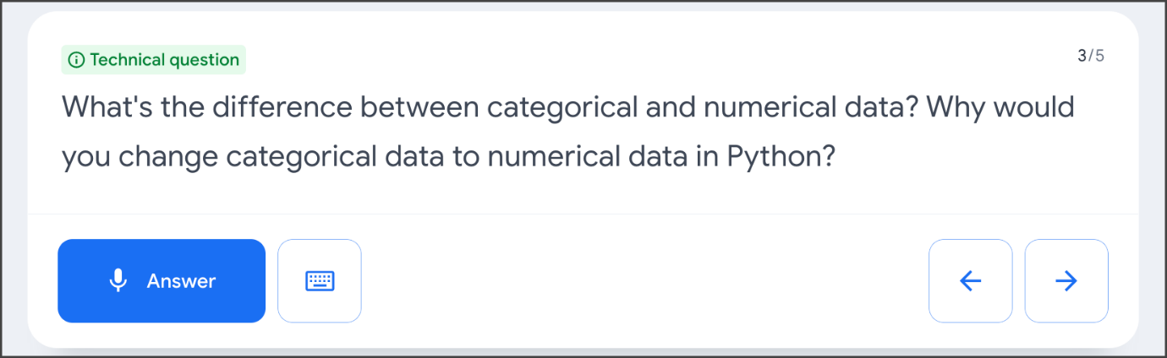

**Get started**

Follow these steps to start a five-question practice interview related to advanced data analytics:

1. Go to [grow.google/interview-warmup](http://grow.google/interview-warmup).
2. Click **Start practicing**.
3. Select **Data Analytics** to open an additional menu.
4. Select **Advanced Data Analytics** as the field you wish to practice.
5. Click **Start**.

The interview lasts about 10 minutes, and the questions will vary with each attempt. During each interview session, you will be asked two background questions, one behavioral question, and two technical questions. You are encouraged to try as many practice interviews as you want.

You can also review complete lists of [data analytics interview questions](https://grow.google/certificates/interview-warmup/category/advanced-data-analytics/all-questions/) or [general interview questions](https://grow.google/certificates/interview-warmup/category/general/all-questions/) if you'd like to focus on a particular topic.

**How it works**

Interview Warmup asks you interview questions to practice delivering your responses verbally. Your answers will be transcribed in real time, allowing you to review how you responded. In addition, Interview Warmup's machine learning algorithm can detect insights that can help you learn more about your answers and improve the way you communicate.

Here are a few examples of questions Interview Warmup might ask:

* Describe a successful workflow for a data project. What makes this workflow effective?
* Tell me about a time that you struggled with exploratory data analysis. What was the source of your struggle? What did you learn as a result?
* Explain a probability distribution that is not normal and how to apply that in the workplace.
* How do you evaluate the performance of a linear regression model?
* What are two types of machine learning, and what are the distinctions between them?

Here are some of the insights that Interview Warmup provides:

* **Talking points:** The tool lets you know which topics you covered in your answer, such as your experience, skills, and goals. You’ll also be able to view other topics that you might want to consider covering.
* **Most-used words:** The tool highlights the words you used most often and suggests synonyms to broaden your word choices.
* **Job-related terms:** The tool highlights the words you used that are related to the role or industry in which you are preparing to work. You’ll also be able to view an entire list of job-related terms that you might want to consider including in your answer.

Interview Warmup gives you the space to practice and prepare for interviews on your own. Your responses will be viewable only by you, and they won’t be graded or judged.

**Key takeaways**

Practicing for interviews is an important step in furthering your career in data analytics. Using Interview Warmup can help you practice interview questions and receive feedback in real time. As you practice, you will gain confidence and be able to prepare more polished responses for common interview questions.

**Activity: Optimize your resume**

To pass this optional practice quiz, you must receive 100%, or 1 out of 1 point, by completing the following activity. You can learn more about graded and practice items in the [course overview](https://www.coursera.org/learn/google-advanced-data-analytics-capstone/supplement/jh70x/course-7-overview).



**Activity Overview**



When applying for jobs as a data professional, it’s important that you present an effective resume. A compelling resume that showcases your relevant skills and experience can directly impact your chances of becoming a candidate for a position.

In this activity, you will revise your current resume to reflect the experiences, technical abilities, knowledge, and skills you’ve developed in this program. This will ensure that your resume is tailored for data professional roles and will help you stand out to potential employers.

Be sure to complete this activity before moving on. The next course item will provide you with a completed exemplar to compare to your own work. You will not be able to access the exemplar until you have completed this activity.

**Scenario**



Review the following scenario. Then complete the step-by-step instructions.

To refine your resume for roles in the data analytics field, you will first search for and identify a target role. Then, you will tailor the content in your resume to match the requirements of that role.

To review some best practices for developing a data professional resume, refer to the following reading: [Resume writers’ workshop](https://www.coursera.org/learn/google-advanced-data-analytics-capstone/supplement/x6Wxp/resume-writers-workshop).

**Note**: Resumes can be presented in a variety of different formats, and some of the sections in your resume might differ from those described in this activity. What is most important is that you update your resume to reflect the skills you’ve gained in this program and that the language you use is applicable to the position you’ve identified.

**Step-By-Step Instructions**



Follow the instructions to complete each step of the activity. Then, answer the questions at the end of the activity before going to the next course item to compare your work to a completed exemplar.

**Step 1: Access your resume**

To begin, open your current resume. If you don’t already have a resume, be sure to complete the following activity before continuing: [Build a resume](https://www.coursera.org/learn/google-advanced-data-analytics-capstone/quiz/K6ahR/activity-build-a-resume).

Step 2: Research roles

Think about what you’ve learned about data professional roles in this program so far, and decide which type of role you would like to pursue. Refer to the following reading to review some of the different types of roles available in this field: [Profiles of data professionals](https://www.coursera.org/learn/foundations-of-data-science/item/s9Slc).

Consider the tasks and responsibilities that interest you, your current skill set, and your previous experience. Then, research roles on platforms like [Indeed](https://www.indeed.com/), [LinkedIn Job Search](https://www.linkedin.com/jobs/), or [CareerBuilder](https://www.careerbuilder.com/) and identify a position that appeals to you.

Step 3: Complete the email to the new public relations writer

Step 4: Update your personal information

Step 5: Update your skills

Step 6: Update your experience

Step 7: Update your education

Step 8: Add what makes you unique

Step 9: Proofread your resume

**What to Include in Your Response**



Be sure to address the following components in your completed resume:

* Your **personal information**, including your name, job title, address, phone number, email address, and links to your LinkedIn profile and portfolio
* The **skills** you have that align most closely to data analytics and the specific job posting
* Your **work experience**, including each company name and location, your job title, the dates you worked there, and a description of your responsibilities
* Your **education**, including the name of each institution and its location; the degree, diploma, or certificate you earned; and the dates you attended
* A section(s) that highlight(s) what makes you unique

Your resume should also:

* Use correct grammar, spelling, and punctuation
* Be no more than 1–2 pages in length

**1.**

Question 1

**Did you complete this activity?**

Status: [object Object]

1 / 1 point

Yes

No

Correct

Thank you for completing this activity! A well-crafted, professional resume that connects your skills and experiences to data professional roles is a valuable tool when applying for jobs in the field. Please complete the following quiz questions and review the feedback. Then go to the next course item to compare your work to a completed exemplar.

**2.**

Question 2

Which of the following actions can you take to help you tailor your resume to data professional roles? Select all that apply.

Status: [object Object]

1 / 1 point

Refer to previous course content to review some of the different types of roles available in data analytics.

Correct

Reviewing [the reading that profiles data professionals](https://www.coursera.org/learn/foundations-of-data-science/item/s9Slc), reflecting on how your skills and experience relate to those roles, and researching data professional jobs on job platform sites can help you tailor your resume to those roles.

Consider how your current skill set and previous experience relate to data professional roles.

Correct

Reflecting on how your skills and experience relate to data professional roles, reviewing [the reading that profiles data professionals](https://www.coursera.org/learn/foundations-of-data-science/item/s9Slc), and researching data professional jobs on job platform sites can help prepare you to tailor your resume to those roles.

Research roles on job-search platforms and take notes on some of the skills and qualifications required for jobs that appeal to you.

Correct

Researching data professional jobs on job platform sites, reviewing [the reading that profiles data professionals](https://www.coursera.org/learn/foundations-of-data-science/item/s9Slc), and reflecting on how your skills and experience relate to data professional roles can help you tailor your resume to those roles.

Select an elaborate resume design that will make you stand out to potential employers and recruiters.

**3.**

Question 3

What should you include in the experience section on your resume? Select all that apply.

Status: [object Object]

1 / 1 point

Your job responsibilities and accomplishments

Correct

The experience section of your resume should list at least three positions in reverse chronological order, communicate how your responsibilities and accomplishments relate to the role you are applying for, and highlight your transferable skills.

Your three previous positions

Correct

The experience section of your resume should list at least three positions in reverse chronological order, communicate how your responsibilities and accomplishments relate to the role you are applying for, and highlight your transferable skills.

Your past salaries

Your transferable skills

Correct

The experience section of your resume should list at least three positions in reverse chronological order, communicate how your responsibilities and accomplishments relate to the role you are applying for, and highlight your transferable skills.

**4.**

Question 4

What issues should you address when proofreading your resume? Select all that apply.

Status: [object Object]

1 / 1 point

Include written recommendations from past employers

Consolidate your resume to no more than 1–2 pages

Correct

When proofreading your resume, be sure to fix spelling, grammatical, and punctuation errors. You should also revise your wording to be as concise as possible and consolidate your resume to 1–2 pages. These checks will help ensure that your resume is succinct, professional-looking, and easy to read.

Correct any spelling, grammatical, and punctuation errors

Correct

When proofreading your resume, be sure to fix spelling, grammatical, and punctuation errors. You should also revise your wording to be as concise as possible and consolidate your resume to 1–2 pages. These checks will help ensure that your resume is succinct, professional-looking, and easy to read.

 Revise your wording to be as concise as possible

Correct

When proofreading your resume, be sure to fix spelling, grammatical, and punctuation errors. You should also revise your wording to be as concise as possible and consolidate your resume to 1–2 pages. These checks will help ensure that your resume is succinct, professional-looking, and easy to read.

**Get started with LinkedIn**

**Signing up**

Signing up with LinkedIn is simple. Just follow these simple steps:

1. Browse to [linkedin.com](https://www.linkedin.com/)
2. Click **Join now** or **Join with resume**.

If you clicked **Join now**:

1. Enter your email address and a password and click **Agree & Join** (or click **Join with Google** to link to a Google account).
2. Enter your first and last name and click **Continue**.
3. Enter your country/region, your postal code, and location with the area (this helps LinkedIn find job opportunities near you).
4. Enter your most recent job title, or select **I’m a student**.
5. If you entered your most recent job title, select your employment type and enter the name of your most recent company.
6. If you selected self-employed or freelance, LinkedIn will ask for your industry.
7. Click confirm your email address. You will receive an email from LinkedIn.
8. To confirm your email address, click **Agree & Confirm** in your email.
9. LinkedIn will then ask if you are looking for a job. Click the answer that applies. If you select Yes, LinkedIn will help you start looking for job opportunities.

If you clicked **Join with resume**:

1. Click **Upload your resume** and select the file to upload.
2. Follow any of the steps under **Join Now** that are relevant.

The Join with resume option saves you some time because it auto-fills most of the information from your resume. And just like that, your initial profile is now ready!

**Including basic information in your profile**

It is a good idea to take your time filling out every section of your profile. This helps recruiters find your profile and helps people you connect with get to know you better. Start with your photo. Here are some tips to help you choose a great picture for your new profile:

* Choose an image that looks like you: You want to make sure that your profile is the best representation of you and that includes your photo. You want a potential connection or potential employer to be able to recognize you from your profile picture if you were to meet.
* Use your industry as an example: If you are having trouble deciding what is appropriate for your profile image, look at other profiles in the same industry or from companies you are interested in to get a better sense of what you should be doing.
* Choose a high-resolution image: The better the resolution, the better impression it makes, so make sure the image you choose isn’t blurry. The ideal image size for a LinkedIn profile picture is 400 x 400 pixels. Use a photo where your face takes up at least 60% of the space in the frame.
* Remember to smile: Your profile picture is a snapshot of who you are as a person so it is okay to be serious in your photo. But smiling helps put potential connections and potential employers at ease.



**Adding connections**

Connections are a great way to keep up to date with your previous coworkers, colleagues, classmates, or even companies you want to work with. The world is a big place with a lot of people. So here are some tips to help get you started.

1. Connect to people you know personally.
2. Add a personal touch to your invitation message. Instead of just letting them know you would like to connect, let them know why.
3. Make sure your profile picture is current so people can recognize you.
4. Add value. Provide them with a resource, a website link, or even some content they might find interesting in your invitation to connect.

**Finding leaders and influencers**

LinkedIn is a great place to find great people and great ideas. From technology to marketing, and everything in between, there are all kinds of influencers and thought leaders active on LinkedIn. If you have ever wanted to know the thoughts of some of the most influential and respected minds in a certain field, LinkedIn is a great place to start. Following your favorite people takes only a few minutes. You can search for people or companies individually, or you can use these lists as starting points.

[Top influencers on LinkedIn](https://lists.linkedin.com/2015/top-voices/influencers) [LinkedIn Top Voices 2020: Data Science & AI](https://www.linkedin.com/pulse/linkedin-top-voices-2020-data-science-ai-jessi-hempel/)

**Looking for a new position**

On LinkedIn, letting recruiters and potential employers know that you are in the market for a new job is simple. Just follow these steps:

1. Click the **Me** icon at the top of your LinkedIn homepage.
2. Click **View profile**.
3. Click the **Add profile** section drop-down and under Intro, select **Looking for a new job**.

Make sure to select the appropriate filters for the new positions you might be looking for and update your profile to better fit the role that you are applying for.

**Keeping your profile up to date**

Add to your profile to keep it complete, current, and interesting. For example, remember to add the Google Data Analytics Certificate to your profile after you complete the program!

**Build connections on LinkedIn**

**Using LinkedIn to connect**

A **connection** is someone you know and trust on a personal or professional basis. Your connections are who make up your network. And when it comes to your network, it is important to remember quality over quantity. So don’t focus on how many connections you have. Instead, make sure that everyone you connect with adds value to your network, and vice versa.

**Inviting those you know versus making cold requests**

Adding connections on LinkedIn is easy. You invite people to join your network, and they accept your invitation. When you send an invitation, you can attach a personal note. Personal notes are highly recommended.

A great way to increase the number of your connections is to invite classmates, friends, teachers, or even members of a club or organization you are in. LinkedIn also gives suggestions for connections based on your profile information. Here's an example (template) that you can use to connect with a former co-worker:

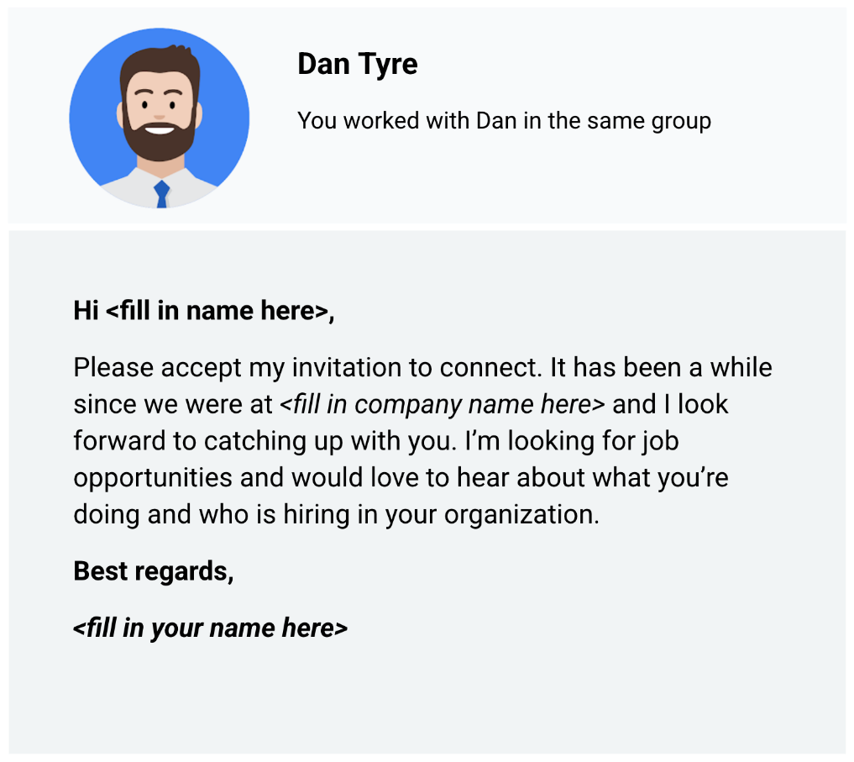The message: Hi <fill in name here>, Please accept my invitation to connect. It has been a while since we were at <fill in company name here> and I look forward to catching up with you. I’m looking for job opportunities and would love to hear about what you’re doing and who is hiring in your organization. Best regards, <fill in your name here>

Cold requests on LinkedIn are invitations to connect with people you don’t know personally or professionally. When you start to build your network, it is best to connect with people you already know. But cold requests might be the only way to connect with people who work at companies you are interested in. You can learn a lot about a company’s culture and job openings from current employees. As a best practice, send cold requests rarely and only when there is no other way to connect.

**Asking for recommendations (references)**

Recommendations on LinkedIn are a great way to have others vouch for you. Ask people to comment on your past performance, how you handled a challenging project, or your strengths as a data analyst. You can choose to accept, reject, show, or hide recommendations in your profile.

Here are some tips for asking for a recommendation:

* Reach out to a variety of people for a 360-degree view: supervisors, co-workers, direct reports, partners, and clients
* Personalize the recommendation request with a custom message
* Suggest strengths and capabilities they can highlight as part of your request
* Be willing to write a recommendation in return
* Read the recommendation carefully before you accept it into your profile

Sometimes the hardest part of getting a recommendation is creating the right request message. Here's an example (template) that you can use to ask for a recommendation:

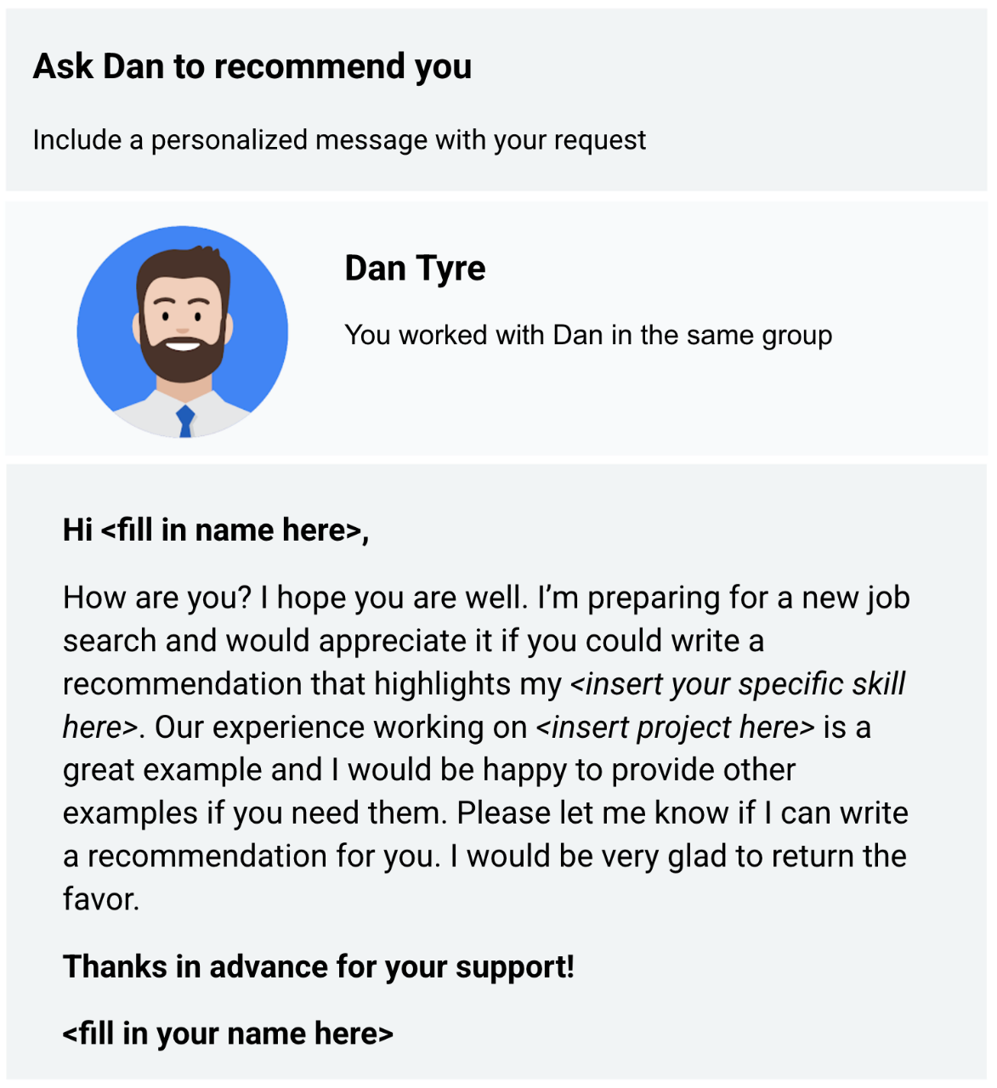Hi <fill in name here>, How are you? I hope you are well. I’m preparing for a new job search and would appreciate it if you could write a recommendation that highlights my <insert your specific skill here>. Our experience working on <insert project here> is a great example and I would be happy to provide other examples if you need them. Please let me know if I can write a recommendation for you. I would be very glad to return the favor. Thanks in advance for your support! <fill in your name here>

Ask a few connections to recommend you and highlight why you should be hired. Recommendations help prospective employers get a better idea of who you are and the quality of your work.

**Summing it up**

When you write thoughtful posts and respond to others genuinely, people in and even outside your network will be open and ready to help you during your job search.

**Activity: Build a resume**

**1.**

Question 1



**Activity Overview**



Earlier, you learned about what makes an effective resume. In this activity, you’ll begin building your resume or work on your existing one.

By the time you complete this activity, you’ll have a stronger understanding of common resume formats and decide on a template for your data analytics resume that you’ll complete later. This is an important part of the job application process: A strong resume is essential to moving forward as a data analytics professional.



**What you will need**

To use the templates for this course item, click the following links and select “Use Template.”

Link to template 1: [Template Example 1](https://docs.google.com/document/d/1qn_zOg-0E7pca6bEk6BGIEBNBuIZdiPnwOTKm76Q-jA/template/preview)

Link to template 2: [Template Example 2](https://docs.google.com/document/d/1l-aMPMNRxZ0zSOQcNGg4jMqQO5FW1coZiV2m7jz6CFw/template/preview)

OR

If you don’t have a Google account, you can download the templates directly from the following attachments.

[Resume Template 1](https://d3c33hcgiwev3.cloudfront.net/ufNix5roSVGzYsea6JlR4A_68e010ef3f8f4d8d92978d8c1cbf7184_Resume-Template-1.docx?Expires=1727308800&Signature=PcCE-Sq-z7jQaU0F2FL1Ht6-ciGLI9Ve2xwuPTNjX~GBSBaBKr~RGkB2yjtvIufUs8GsAJ442Xib7Eso2d86uJ57Kj9-SH4Ss0e0oc9N8syN-vE9ILSdz-vBNPSARFZIiCbUN2wyldJprLHnbE53-EUjwXvlTQT4RUH0jaQtmT4_&Key-Pair-Id=APKAJLTNE6QMUY6HBC5A" \t "_blank)

[DOCX File](https://d3c33hcgiwev3.cloudfront.net/ufNix5roSVGzYsea6JlR4A_68e010ef3f8f4d8d92978d8c1cbf7184_Resume-Template-1.docx?Expires=1727308800&Signature=PcCE-Sq-z7jQaU0F2FL1Ht6-ciGLI9Ve2xwuPTNjX~GBSBaBKr~RGkB2yjtvIufUs8GsAJ442Xib7Eso2d86uJ57Kj9-SH4Ss0e0oc9N8syN-vE9ILSdz-vBNPSARFZIiCbUN2wyldJprLHnbE53-EUjwXvlTQT4RUH0jaQtmT4_&Key-Pair-Id=APKAJLTNE6QMUY6HBC5A" \t "_blank)

[Resume Template 2](https://d3c33hcgiwev3.cloudfront.net/S0mDPfhiSoaJgz34YvqGxA_48ad285cfea74858a876be2ef64c4a49_Resume-Template-2.docx?Expires=1727308800&Signature=X2U3VhAhw0hMXTx-fgaaoT2Y0qcoyBMwmCAi~TVQ3aRHi01A8DU3Nc01l8chuOvTSmCi5jLb0elN4tfO5GlGDaAuKX2lPXZpLikWi5T~XDDXu6~8QNJUfGiYD2G0Pv10gWI~rSQEZ4zYIh06KbjJ3QUhMIllXwmsOFTxHn38y7s_&Key-Pair-Id=APKAJLTNE6QMUY6HBC5A" \t "_blank)

[DOCX File](https://d3c33hcgiwev3.cloudfront.net/S0mDPfhiSoaJgz34YvqGxA_48ad285cfea74858a876be2ef64c4a49_Resume-Template-2.docx?Expires=1727308800&Signature=X2U3VhAhw0hMXTx-fgaaoT2Y0qcoyBMwmCAi~TVQ3aRHi01A8DU3Nc01l8chuOvTSmCi5jLb0elN4tfO5GlGDaAuKX2lPXZpLikWi5T~XDDXu6~8QNJUfGiYD2G0Pv10gWI~rSQEZ4zYIh06KbjJ3QUhMIllXwmsOFTxHn38y7s_&Key-Pair-Id=APKAJLTNE6QMUY6HBC5A" \t "_blank)



**Format your resume**



First, you’ll make some decisions about the structure and layout of your resume. You’ll start by examining the two templates and decide which format you like best. Spend some time browsing the templates, as well as templates available to you on the web. Take note of the things you like or dislike about the various formats. It’s okay to take some time and be selective here. You’ll be spending a lot of time on this document, so picking a format you’re happy with will help you get off to a strong start.

**Formats and templates**



Before creating your resume, you need to make some design decisions. While you may make some small tweaks and changes to tailor the content of your resume to specific roles you are applying for, the structure and format of the resume likely won’t change. This means it is important to spend time thinking about how you’ll want to structure your resume.

**Keep your resume format concise**



There’s no “best” format for a resume. Instead, think about what you want to highlight about yourself to potential employers.

For instance, if you have relevant work experience, then pick a format to highlight that.

If you are transitioning from a different career and don’t yet have relevant work experience, then you may want to pick a format that highlights your technical skills and portfolio projects. Some resume formats include a **Summary** or **Goals** section at the top to help candidates add context to their application, while other resume formats avoid these sections completely and save that space for sections such as **Skills** and **Experience**.

Whatever format you pick, make sure to follow the one-page rule and keep the completed version on just a single page. If the one-page rule seems limiting, think about the purpose resumes serve in the hiring process overall. Resumes are short documents designed to communicate the most pertinent information about yourself to recruiters and hiring managers at a glance. These are different from longer, multi-page Curriculum Vitaes (CVs) that exhaustively list every relevant thing the candidate has ever done.

If an employer wants a detailed history of your past work experiences and accolades, they might specifically request a CV (curriculum vitae) instead. If they don’t, always assume they prefer a resume. While it is generally considered acceptable for resumes of applicants with extensive work history applying for senior technical roles to have two-page resumes, these are the exception rather than the rule. When applying for a data analyst position, keep it to one page!

**Select a format**



Once you decide on a template, resist the urge to begin filling it out. The next lessons will focus on best practices for communicating your skills and experience in meaningful, impactful ways. Keep this resume template handy, as you’ll be working on it further.

**Confirmation and reflection**



What is most important to consider when you select a resume format?

Status: [object Object]

1 point

Which format fits the most content

Which format hiring managers prefer

Aesthetic appeal

What you want to emphasize to potential employers

**2.**

Question 2

In this activity, you chose a template for your resume. In the following text box, write 2-3 sentences (40-60 words) in response to each of the following questions:

* What did you like best about the resume template you selected?
* Were there any other templates that caught your attention?
* What would you change about the template you chose to help highlight your relevant skills and experience to potential employers?

I liked the clean and modern design of the resume template I selected, as it highlights key sections like skills and experience clearly, making it easy for employers to scan. Another template that caught my attention was one with a more creative layout. I would adjust the font size and add a section for certifications to further emphasize my qualifications.

## **Module 3:**

**Showcase your work**

Congratulations on earning your Google Advanced Data Analytics Certificate! Now it’s time to let the world know about the skills you gained to help advance your career and share some of the artifacts you created along the way. We recommend adding the completion of this certificate to your resume and LinkedIn® profile. Read on and follow these tips to get started.

**Adding the Google Advanced Data Analytics Certificate to your resume and LinkedIn® profile**

You may have already started on a data professional resume earlier in the certificate. If not, there are a variety of digital templates for creating your resume available at [Enhancv](https://app.enhancv.com/industry-examples), [Big Interview](https://googlecerts.biginterview.com/), [Google Docs](https://applieddigitalskills.withgoogle.com/c/middle-and-high-school/en/create-a-resume-in-google-docs/overview.html) or [Microsoft Word.](https://support.microsoft.com/en-us/office/use-a-template-to-create-a-resume-6053fbbb-94d8-471e-9957-49f4e7ab6fb8)You can find additional resume creation guidance in this lesson from [Applied Digital Skills: Start a Resume](https://applieddigitalskills.withgoogle.com/c/college-and-continuing-education/en/start-a-resume/overview.html)

**Update your Education or Licenses and Certifications section**

* To add the completion of this certificate to your resume, update your ***Education*** or ***Licenses & Certifications*** section.
* To add the completion of this certificate to the ***Licenses & Certifications*** section of your LinkedIn® profile, follow the [steps listed in this article.](https://www.linkedin.com/help/linkedin/answer/44644)

Consider this example of how you might format your Education on your resume:

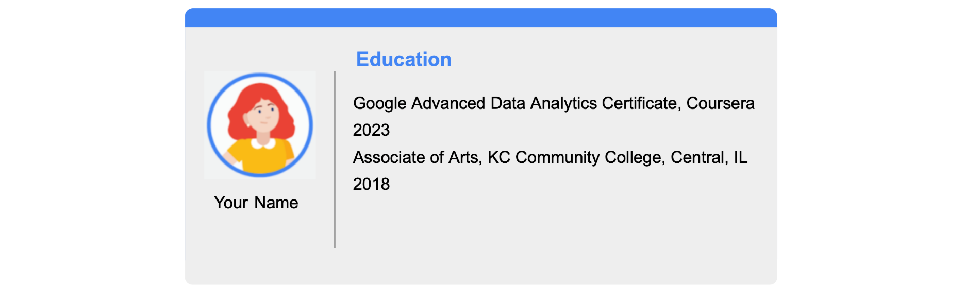

**Update your Skills section**

* If applicable, update the ***Skills*** section of your resume with the skills you gained in this program. Below is a comprehensive list of the skills that this certificate was designed to help you develop. Consider adding some or all of these to your resume.
* To update the ***Skills & Endorsements*** section of your LinkedIn® profile, follow the [steps listed in this article.](https://www.linkedin.com/help/linkedin/answer/4976)

Here is an example of some relevant skills that you might find on a data professional’s resume.

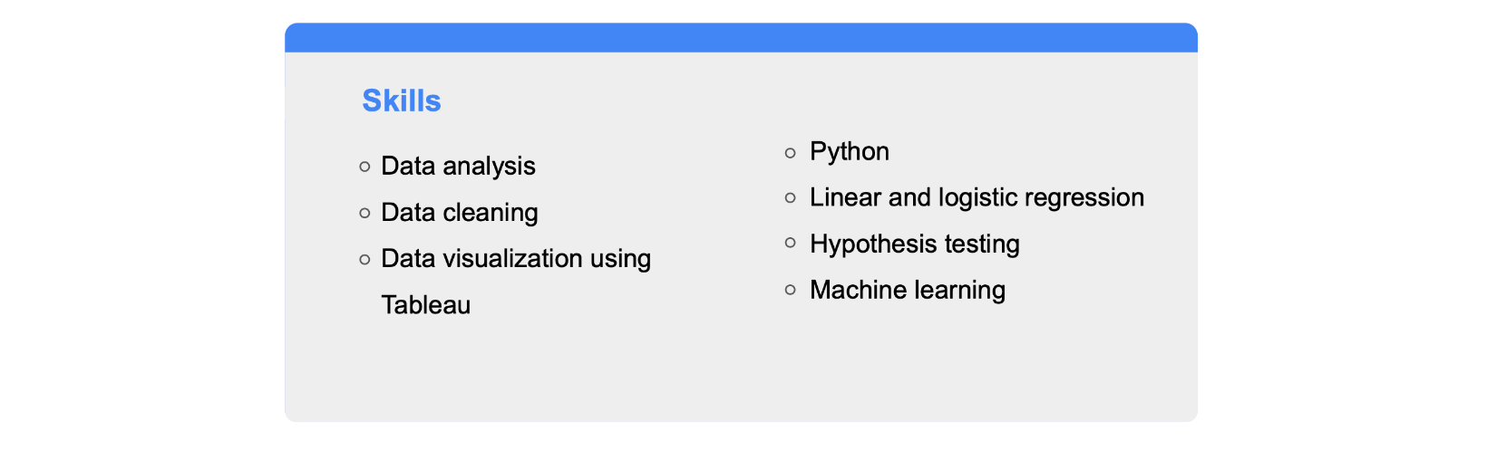

**Update your Summary or About section**

* If you have a ***Summary*** section in your resume, you can include this certificate as a qualification.
* To include a summary that mentions this certificate in your LinkedIn® profile, update your ***About*** section by following the [steps listed in this article.](https://www.linkedin.com/help/linkedin/answer/92157)

Here is an example of a professional summary:

Versatile individual with experience in exploratory data analysis, data visualization, hypothesis testing, logistic regression, and machine learning models like Naive Bayes and decision trees. Excellent understanding and proficiency of platforms for effective data analysis, cleaning, and visualization, including spreadsheets, Python, and Tableau. Strong communication, organizational, and analytical skills. Recently completed the Google Advanced Data Analytics Certificate—a rigorous, hands-on program that covers the entire scope of the data analysis and data modeling process.

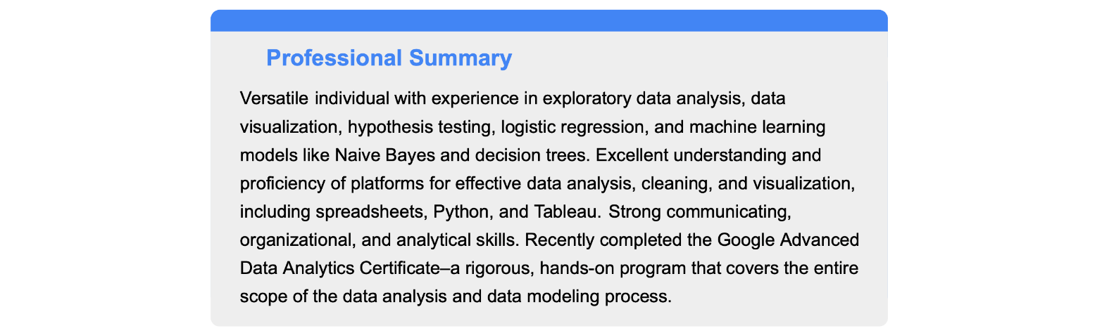

**Add your badge**

Access the next course item to learn how to claim your certificate completion badge and add it to your LinkedIn® profile!

**Claim your Google Advanced Data Analytics Certificate badge**

Learners who complete all courses of this certificate are eligible to earn a digital badge from Credly and Google.

More details are in the frequently asked questions sections (FAQs) below. For any other questions, including issues with your certificate, please contact [Coursera Learner Services](https://learner.coursera.help/hc/en-us).

**About badges**

**What is a badge?**

* A badge is a visual representation of a verified credential you’ve earned. In this case, your credential is the Google Advanced Data Analytics Certificate! You’ll get a badge upon completion of the program that you can share on platforms like LinkedIn® to catch the attention of potential employers.

**What is Credly and Acclaim?**

* Acclaim is a badging platform that’s part of Credly, a leading digital credential service provider. Acclaim provides badges so that you can easily share your achievements to online destinations like LinkedIn®, and employers can instantly verify your skills.

**How do I add my badges to my LinkedIn® profile?**

* Follow the steps in this [Credly article](https://support.credly.com/hc/en-us/articles/360021221491-How-can-I-add-my-badge-to-my-LinkedIn-profile-and-share-to-my-feed-) to add your badge to your LinkedIn® profile. You can also watch this [YouTube video](https://www.youtube.com/watch?v=I19hmgYmsI4) for step-by-step instructions.

**About the Google badge**

**How do I claim my badge for completing the Google Advanced Data Analytics Certificate?**

* Upon completion of the certificate, you will receive an email letting you know you have earned a badge. From the email, you can choose to claim the badge and opt in to share your information for the purposes of badge issuing. If you decide to claim the badge, Coursera will then send a request to Acclaim to issue your badge. If you don’t have an Acclaim account yet, you will be asked to create one before you can accept and view your badge.
* Please allow at least one week from your date of completion for the system to update. Make sure to check your spam folder just in case it ends up there!

**I completed the Google Advanced Data Analytics Certificate. What do I do if I have not received an email invite to claim my badge?**

* If you’ve waited a week since you completed the certificate and haven’t received an email, please submit a request through the [Credly Help Center.](https://support.credly.com/hc/en-us)

**Take the next step with Google AI Essentials**

Congratulations on completing the Google Advanced Data Analytics Certificate!

If you’re ready to hone your skills and take your AI expertise to the next level — the Google AI Essentials course is the perfect next step!

[Google AI Essentials](https://www.coursera.org/learn/google-ai-essentials?utm_medium=sem&utm_source=gg&utm_campaign=B2C_NAMER_google-ai-essentials_google_FTCOF_learn_country-US-country-CA&campaignid=21236345441&adgroupid=164614892067&device=c&keyword=google%20ai%20essentials%20course&matchtype=b&network=g&devicemodel=&adposition=&creativeid=697863018869&hide_mobile_promo&gad_source=1&gclid=Cj0KCQjw0_WyBhDMARIsAL1Vz8s1l186GIRMCcSWV4KKLmoSqHw94e76-8710eny44cBQQxAabTrf7EaAi8BEALw_wcB) is a self-paced course designed to help people across roles and industries get essential AI skills to boost their productivity, zero experience required. The course is taught by AI experts at Google who are working to make the technology helpful for everyone. In under 10 hours, they’ll do more than teach you about AI — they’ll show you how to actually use it in your day-to-day work.

* Stuck at the beginning of a project? You’ll learn how to use AI tools to generate ideas and content.
* Planning an event? You’ll use AI tools to help research, organize, and make more informed decisions.
* Drowning in a flooded inbox? You’ll use AI tools to help speed up those daily work tasks like drafting email responses.

You’ll also learn how to write effective prompts and use AI responsibly by identifying AI’s potential biases and avoiding harm. After you complete the course, you’ll earn a certificate from Google to share with your network and employer. By using AI as a helpful collaboration tool, you can set yourself up for success in today’s dynamic workplace — and you don’t even need programming skills to use it.

**Resources for Google Advanced Data Analytics Certificate graduates**

**1.**

Question 1

**Have you finished all seven courses in the Google Advanced Data Analytics Certificate?**

Congratulations on completing the Google Advanced Data Analytics Certificate! Your dedication has unlocked exclusive career-boosting resources and benefits. Access and share your badge of completion, receive personalized career guidance, and sharpen your interview skills.

To claim these resources at no cost, simply access each using the same email address you used when registering for the certificate on Coursera. Please note that these benefits are only available to graduates who have completed all seven courses in the Google Advanced Data Analytics Certificate program.

Status: [object Object]

1 / 1 point

**Claim your Google Advanced Data Analytics Certificate badge and share it with your professional network.**

* Look for an email from Credly ([admin@credly.com](mailto:admin@credly.com)) within one week of completing the certificate.
* Claim your badge on Credly’s Acclaim platform using the email address linked to your Coursera account. You’ll need to opt in to share your information for the purposes of badge issuing.
* Add the badge to your LinkedIn to highlight your skills by following the steps in this [Credly article](https://support.credly.com/hc/en-us/articles/360021221491-How-can-I-add-my-badge-to-my-LinkedIn-profile-and-share-to-my-feed-) or [video tutorial](https://vimeo.com/725834127?embedded=true&source=vimeo_logo&owner=149323741).

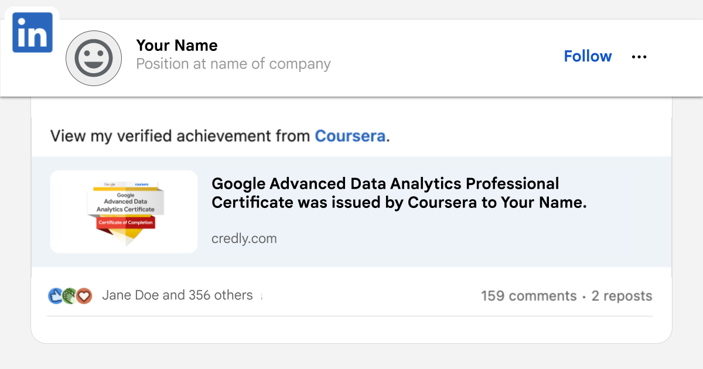

Correct

**Showcase your new skills and expand your professional network.** Share your accomplishment on social media using our [sample posts and prompts](https://drive.google.com/file/d/1f8PpJyjmJS0A0_HA38VTI9kCLcRy1293/view), and include #GrowwithGoogle for greater visibility.

Correct

**Connect with a community of learners and discover new opportunities.** Follow Grow with Google on [LinkedIn](https://www.linkedin.com/showcase/grow-with-google/) to join a network of like-minded individuals and explore further learning possibilities.

Correct

**Get career support from** [**CareerCircle**](https://www.careercircle.com/campaign/coursera) **at no cost (US graduates only).** Google is giving certificate graduates like you free access to career support from CareerCircle, including a resume builder and interview preparation resources to help you land your next job. Plus, you’ll get access to free 1-on-1 career coaching and thousands of job postings from top employers. You must be eligible to work in the U.S. to unlock this resource.

Correct

**Improve your interview technique with** [**Interview Warmup**](https://grow.google/certificates/interview-warmup/)**.** Practice interviewing with Interview Warmup, a tool built by Google with certificate graduates in mind. Access cybersecurity-specific practice questions, transcripts of your responses, and automatic insights that help you grow your skills and confidence.

Correct

**Access free interview practice and job search tips with** [**Big Interview**](https://googlecerts.biginterview.com/)**.** Get practice with mock interviews, job search tips, and customizable resume templates with Big Interview, available free for one year to Google Career Certificate graduates.

Correct

**Inspire others by sharing your story**. Stories from successful graduates, like you, can encourage the next generation of learners to pursue their passions. In addition, your feedback helps us improve the certificate program. Fill out [this short survey](https://docs.google.com/forms/d/e/1FAIpQLSfPm4bP-xfyDKdHtZVZTOJa20oMquyUrEw90Ss4SZgdBYWA7A/viewform) to tell us about your journey.

Correct

**END OF THE COURSE**